TWiG Grant Final Report
to the Big Thicket Association
and the Big Thicket National Preserve

July 2010

K. E. Winsett
S. L. Stephenson

Dept of Biological Sciences, SCEN 632, University of Arkansas, Fayetteville, AR 72701
kwinset@uark.edu, slsteph@uark.edu

Table of Contents

1. Abstract

2. Acknowledgments

3. Introduction

4. Methods
4.1 Site/ Habitat Description
4.2 Field Collecting
4.3 Moist Chamber Culture

5. Results
5.1 Sites Collected
5.2 Field Collections
5.3 Moist Chamber Culture
5.4 Species List
5.5 Outreach

6. Possible Future Research Projects

1. Abstract
Between 2007 and 2010, a general survey of myxomycetes (plasmodial slime molds) was conducted at the Big Thicket National Preserve (BITH). The myxomycetes are eukaryotic organisms found in any habitat where vegetation occurs. These organisms feed on bacteria and single-celled organisms that occur on decaying vegetation. Myxomycetes are collected and identified in the fruiting body stage of the life cycle. In the Big Thicket National Preserve, myxomycetes were collected by the examination of appropriate substrate in the field and through the moist chamber culture technique for substrate analysis in the laboratory. Through these techniques, a total of 745 fruiting body collections were made from 44 different sites in the Preserve.

2. Acknowledgements
We wish to acknowledge the assistance of a number of people who have made the work for this project possible. Our knowledge of the Big Thicket National Preserve was very thin before taking on this initial inventory, and a number of people, both personnel of the Preserve including Dave Roemer and Brian Lockwood and scientists from other Taxonomic Working Groups including David Lewis, Dale Kruse and Paul Roling, were generous with their time and expertise to guide our investigation of the myxomycete variety within the Preserve. The funding from the Big Thicket Association made this project possible considering the significant costs of traveling between Northwest Arkansas and the BITH in Texas.

3. Introduction
The myxomycetes are one of three groups of organisms traditionally recognized as true slime molds (class Eumycetozoa sensu Olive 1975). One group, the myxomycetes, are small, eukaryotic amoeboid organisms with trophic stages that feed upon populations of bacteria and other microorganisms associated with decaying plant material in all types of terrestrial habitats. There are approximately 900 species of myxomycetes known worldwide (Lado 2001) that occur in terrestrial habitats where vegetation is present. They are found at high and low latitudes including the Antarctic Peninsula as well as temperate and tropical ecosystems. Many species have a global distribution occurring in many varied ecosystems worldwide (Stephenson and Stempen 1994).

There is precedent set for the survey of myxomycetes in conjunction with the All Taxa Biodiversity Inventory within the National Park System. Since 1998, an ongoing survey of myxomycetes within the Great Smoky Mountains National Park (GSMNP) has resulted in an increase of known species for the park from 88 to 220 species (Stephenson and Landolt 2009). The methods and expertise from that survey were used to develop and implement this inventory at BITH.

Before this study in the BITH, there were no official records of slime molds for the Preserve. The only records of myxomycetes known from the literature were collected before the preserve was established (McGraw 1968, Alexopoulos and Henney 1971). Using the collecting data from these older collections, however, it is known that myxomycetes were collected in the same region as the BITH.

Between 2007 and 2010, a general survey of myxomycetes was conducted at the Big Thicket National Preserve (BITH) in association with the Thicket of Diversity All Taxa Biodiversity Inventory (ToD ATBI) to develop an initial understanding of the diversity of these organisms within the Preserve. Five field trips to the BITH were made by K. Winsett to collect substrate material for moist chamber culture and any fruiting bodies found in the field from as many different Preserve units and habitat types as possible.

4. Methods
4.1 Site/ Habitat Description
The ecological description of sites that were collected for myxomycetes follows the descriptions in Watson 2006. General ecoregion types were assigned based upon the BITH general vegetation map: Arid Sandylands, Baygall, Bottomland Hardwood Forest, Cypress Slough, Longleaf Pine Uplands, Palmetto Hardwood Flats, Slope Forest, Wetland Pine Savannah. (Figure 1). As this map is a general representation of the ecoregions of the BITH, appropriate ecoregion was assigned based upon first person observation along with the location of the site on the available map.

4.2 Field Collecting
At all collecting sites, appropriate substrate (generally dead, decorticated woody debris on the ground) was examined for fruiting bodies of myxomycetes. At least one collection of each species found was collected by removing the substrate upon which it was fruiting with a pocketknife and brought back to the lab for species identification and preparation for herbarium storage. Collections were allowed to air dry then the substrate with the fruiting bodies was glued onto a paper tray that fits into a cardboard pill box. The species was identified using the keys in Martin and Alexopoulos (1969). All specimens are stored in the myxomycete herbarium (UARKM) at the University of Arkansas in Fayetteville, AR, with duplicates deposited at the S.M. Tracy Herbarium (TAES) at Texas A&M University in College Station, TX

4.3 Moist Chamber Culture
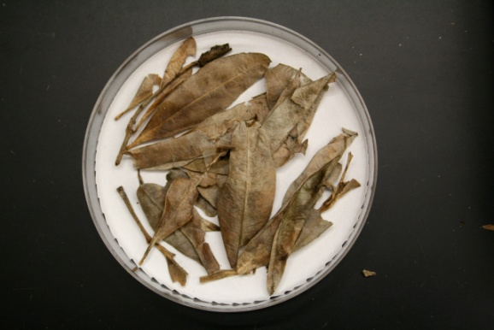
Substrate material was collected at each field site and cultured in the laboratory to get fruiting bodies of myxomycetes. Four general types of substrate were collected: aerial litter (dead plant material still attached to the plant and off of the ground), bark (outer bark from living trees), coarse woody debris (woody material including twigs from the ground), ground litter (dead plant material from the ground). All substrate material was collected in brown paper lunch bags. In the laboratory, three moist chamber cultures (image) were set up for each substrate collection. A moist chamber was a Petri dish fitted with a piece of filter paper on the bottom. Substrate material was placed in roughly a single layer on the filter paper. The material was covered with distilled water and left overnight. After 24 hours, the pH was measured in the standing water after which most of the water was poured off. Moist chambers were stored on a shelf in indirect light and checked for the presence of myxomycetes (plasmodium or fruiting body) once a week for 10 weeks. All fruiting bodies were removed and prepared for herbarium storage as described above.

5. Results
5.1 Sites Collected
Over the course of four collecting trips in the preserve (June 2007, March 2008, October 2009, June 2010), substrate material was collected in a total of 44 sites in Beaumont Unit, Beech Creek Unit Big Sandy Unit Canyonlands Unit, Hickory Creek Savannah Unit, Jack Gore Baygall Unit, Lance Rosier Unit, Little Pine Island Bayou Corridor Unit, Loblolly Unit, Menard Creek Corridor Unit, and the Turkey Creek Unit (Figure 2).

5.2 Field Collections
A total of 282 collections of fruiting bodies found in the field were identified and deposited at the University of Arkansas Myxomycete Collection (UARKM).

5.3 Moist Chamber Culture
From 552 moist chambers prepared [June 2007 (294), Mar 2008 (50), Oct 2009 (208)], a total of 463 collections were made from substrate material collected in the field and processed in the lab using the moist chamber culture technique. At the time this report was in preparation, the substrate material from the June 2010 field trip was not processed. The number of moist chambers, therefore will increase by at least 100 plates. It follows that the number of collections, and possible the number of species will change as a result of those moist chambers.

5.4 Data and Species List
Complete data to date including ecological, substrate and locality information is available through the Thicket of Diversity database (contact: Mona Halvorson, database@bigthicket.org).

From this collecting effort, 81 different species were collected within BITH. Following the scientific name in the species list are abbreviations representing the park units in which each species was found: Beaumont – B; Beech Creek – BC; Big Sandy – BS; Canyonlands – CL; Hickory Creek Savannah – HCS; Jack Gore Baygall – JGB; Lance Rosier – LR; Little Pine Island Bayou Corridor – LPIB; Loblolly – L; Menard Creek Corridor – MCC; Turkey Creek – TC.

Arcyria cinerea (Bull.) Pers. B, BC, BS, CL, HCS, JGB, LR, LPIB, L, MCC, TC; both digitate and singular forms
Arcyria denudata (L.) Wettst. BS, CL, HCS, LR, LPIB, L, MCC, TC
Arcyria margino-undulata Nann.-Bremek. & Y. Yamam. MCC
Arcyria pomiformis (Leers) Rostaf. BC, JGB
Badhamia melanospora (Speg.) HCS
Calonema aureum (Morgan) HCS
Ceratiomyxa fruticulosa (O.F. Mϋll.) T. Macbr. B, BS, HCS, JGB, LR, L
Clastoderma debaryanum A. Blytt BS, HCS, LR, TC
Collaria arcyrionema (Rostaf.) Nann.-Bremek. ex Lado B, BC, BS, CL, HCS, JGB, LR, LPIB, L, MCC, TC
Collaria lurida (Lister) Nann.-Bremek. HCS
Comatricha elegans (Racib.) G. Lister BS, HCS, JGB, LR
Comatricha laxa Rostaf. CL
Comatricha nigra (Pers. ex. J.F. Gmel.) J. Schröt. BS, HCS, LR
Comatricha pulchella (C. Bab.) Rostaf. B, HCS, JGB, LR, MCC, TC
Comatricha tenerrima (M.A. Curtis) G. Lister LR
Craterium paraguyense (Speg.) G. Lister CL – one specimen was collected in the Canyonlands on ground litter
Cribraria aurantiaca Schrad. LR
Cribraria cancellata (Batsch) Nann.-Bremek. CL, HCS, LR, L
Cribraria confusa Nann.-Bremek. & Y.Yamam. BS, CL, HCS, JGB, LR
Cribraria intricata Schrad. LR, LPIB, L
Cribraria languescens Rex HCS, JGB, LR, L
Cribraria microcarpa (Schrad.) Pers. HCS, JGB, LR, L, MCC, TC
Cribraria minutissima Schwein. JGB
Cribraria piriformis Schrad. LR
Cribraria tenella Schrad. JGB
Cribraria violacea Rex BS, CL, LR, MCC, TC
Cribraria vulgaris Schrad. L
Diachea leucopodia (Bull.) Rostaf. B, HCS
Diderma chondrioderma (de Bary & Rostaf.) G. Lister CL
Diderma effusum (Schwein.) Morgan B, BS, CL, LR, L, MCC, TC
Diderma hemisphaericum (Bull.) Hornem. BS, CL, HCS, LR
Didymium iridis (Ditmar) Fr. HCS, TC
Didymium minus (Lister) Morgan BS
Didymium nigripes (Link) Fr. CL, HCS, LR, TC
Echinostelium apitectum K.D. Whitney CL, HCS
Echinostelium minutum de Bary BC, CL, HCS, JGB, LR, MCC, TC
Enerthenema papillatum (Pers.) Rostaf. LR
Fuligo septica (L.) F.H. Wigg. HCS, LPIB
Hemitrichia calyculata (Speg.) M.L. Farr B, BS, CL, HCS, LR, LPIB, L, MCC
Licea biforis Morgan MCC
Licea kleistobolus G.W. Martin JGB
Licea operculata (Wingate) G.W. Martin HCS
Lycogala epidendrum (L.) Fr. BC, HCS, JGB, LR, LPIB, L, MCC, TC
Lycogala exiguum Morgan MCC
Macbrideola decapillata H.C. Gilbert LR
Metatrichia vesparia (Batsch) Nann.-Bramek. ex G.W. Martin & Alexop. B, CL, HCS, LR
Perichaena chrysosperma (Curr.) Lister B, BC, BS, CL, HCS, LR, MCC, TC
Perichaena corticalis (Batsch) Rostaf. BS, CL, MCC
Perichaena depressa Lib. B, BS, CL, HCS, LR
Perichaena microspora Penz. & Lister BS
Perichaena vermicularis (Schwein.) Rostaf. BC, MCC
Physarella oblonga (Berk. & M.A. Curtis) Morgan B
Physarum album (Bull.) Chevall. BS, CL, LR, TC
Physarum bivalve Pers. HCS
Physarum crateriforme Petch BS, CL, JGB
Physarum galbeum Wingate HCS, LR
Physarum globuliferum (Bull.) Pers. B, LPIB, L
Physarum leucophaeum FR. BS
Physarum melleum (Berk. & Broome) Massee LR
Physarum nucleatum Rex LR, L
Physarum oblatum T. Macbr. CL
Physarum pusillum (Berk. & M.A. Curtis) G. Lister LR, MCC
Physarum roseum Berk. & Broome LR
Physarum stellatum (Massee) G.W. Martin LR
Physarum tenerum Rex B, L
Physarum viride (Bull.) Pers. BS, HCS, LR, L, MCC, TC
Stemonitis axifera (Bull.) T. Macbr BC, BS, CL, LR, LPIB, MCC
Stemonitis flavogenita E. Jahn LR
Stemonitis fusca Roth BS, CL, HCS, JGB, LR, TC
Stemonitis fusca var nigrescens (Rex) Torrend B, BC, LR, TC – recognized as valid taxon because found in different ecological situation than Stemonitis fusca. STEfus v nig found associated with litter (Martin and Alexopoulos 1969, S.L. Stephenson pers. comm.)
Stemonitis herbatica Peck HCS
Stemonitis smithii T. Macbr. HCS, LR, LPIB – considered a synonym of S. axifera in nomenclatural database. Recognized as separate by Martin and Alexopoulos 1969
Stemonitis splendens Rostaf. LR, LPIB
Stemonitis virginiensis Rex BC
Stemonitopsis typhina (F.H.Wigg.) Nann.-Bremek. B, BS, CL, L
Trichia favoginea (Batsch) Pers. HCS, LR, MCC
Trichia munda (Lister) Meyl. BC, BS
Willkommlangia reticulata (Alb. & Schwein.) Kuntze TC

5.5. Outreach and Contributed Presentations
Winsett, K.E. 2007. Summer Mentor. Eastfield College NSF STEP Big Thicket Summer Institute.
Winsett, K.E. 2007. Myxomycetes Hike at the BioBlitz.
Winsett, KE, SL Stephenson, JM Packard. 2007. Slime Molds of the Big Thicket National Preserve, Taxonomic Working Group of the All Taxa Biodiversity Inventory (ATBI). Mycological Society of America. Baton Rouge, LA.
Winsett, KE, SL Stephenson. 2008. Slime molds of the Big Thicket National Preserve. 6th International Congress on the Systematics and Ecology of Myxomcyetes. Yalta, Crimea, Ukraine.
Winsett, K.E. 2010. An Introduction to the Myxomycetes. Two Day Workshop. 11 participants.

6. Possible Future Research Projects
Ecological study of myxomycetes is a field still for all intents and purposes in its infancy. Because these are microscopic organisms with huge reproductive potential and the ability to disperse by spores over long distances, the design and implementation of ecological study is complex. This baseline diversity data for the Preserve makes this location a good site for future ecological studies like those described below. Because of the scope and diversity within the Preserve, continued inventory work is still a priority.
(a) Submerged Substrate
It is known that the life cycle of slime molds makes it possible for this organism to survive in many types of habitats. There are two resting phases, a spore and an amoeboflagellate cell that can survive and divide by mitosis in aquatic environment. The study of submerged substrate would include culturing, in moist chamber, vegetative material that has been underwater in the diversity of aquatic habitats at BITH including lakes, creeks, rivers, or sloughs.
(b) Bryophyte-Myxomycete Relationship
It is known that myxomycetes will fruit on bryophyte material. Other ongoing study has shown a significant number of species will fruit on bryophytes and some species show a preference for bryophytes as a substrate. Because of the expertise at the BITH Thicket of Diversity (ToD) project, it would be possible to implement such a study within the Preserve to add to and compare with previous data.
(c) Molecular Population Analysis
Molecular analysis of myxomycetes is almost solely limited to systematics—the study of the relationships between and among orders and genera. Only one study addresses questions that address within species relationships (Winsett and Stephenson 2008). More studies of this nature are required to understand the dispersal patterns of species and to develop protocols to investigate the actual biodiversity within the soil ecosystem. Field collecting gives us only the diversity within a snapshot in time. While moist chamber cultures of substrate material enhances the study of the diversity in a site, there is no data describing how comprehensive our knowledge is about the diversity because a significant portion of the life cycle is spent in the soil.

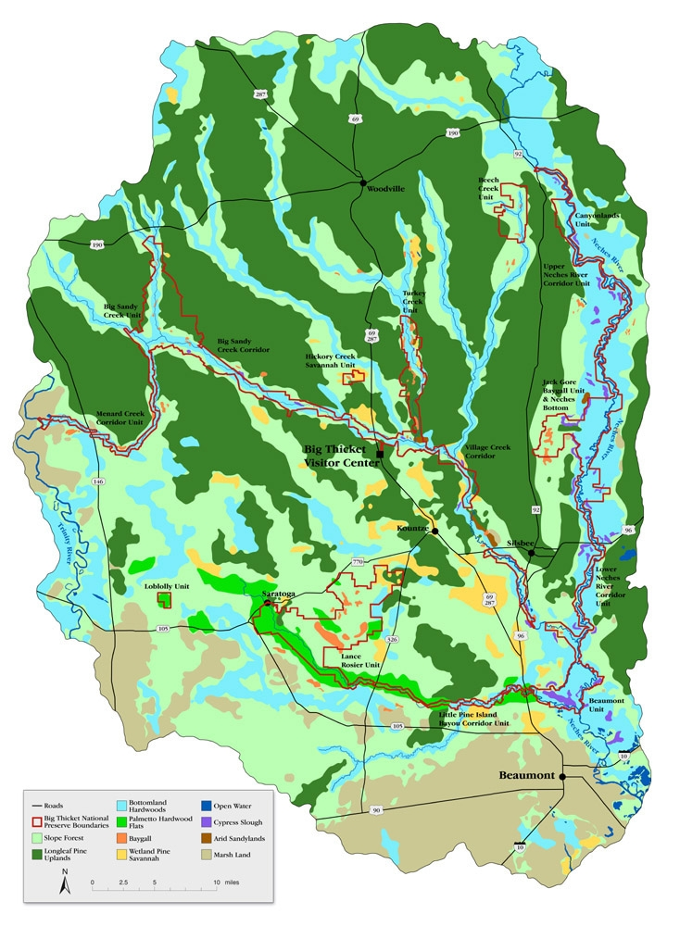
Figure 1. Map of habitat types within the Big Thicket region including BITH preserve boundaries. Map used with permission from Big Thicket National Preserve, National Park Service.
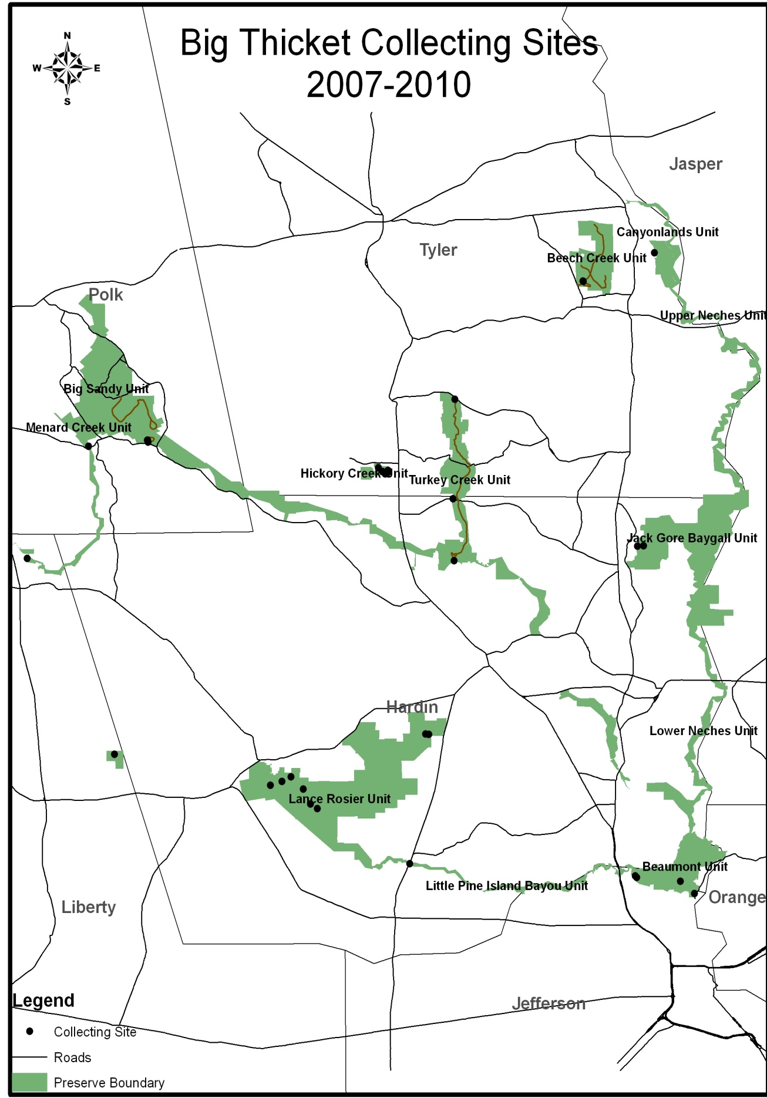
Figure 2. Map of collecting sites based upon GPS point taken at the site at the time of collection.
Literature Cited

Alexopoulos, C. J. And M. R. Henney. 1971. Myxomycetes from Texas. II. Additions and corrections. The Southwestern Naturalist 16: 143-150.

Lado, C. 2001. Nomenmyx, a nomenclatural taxabase of Myxomycetes. Cuadernos de Trabajo de Flora Micológica Ibérica 16: 1-122.

Martin, G.W. and C.J. Alexopoulos. 1969. The Myxomycetes. University of Iowa Press, Iowa City.

McGraw, J. L. 1968. A study of the Myxomycetes of Texas. Ph.D. Dissertation, Texas A&M University, College Station.

Stephenson, S. L. and J. C. Landolt. 2009. Mycetozoans fo the Great Smoky Mountains National Park: and All Taxa Biodiversity Inventory project. Southeastern Naturalist 8: 317-324.

Stephenson, S.L. and H. Stempen. 1994. Myxomycetes: a Handbook of Slime Molds. Timber Press, Portland, Oregon.

Watson, G. E. 2006. Big Thicket Plant Ecology: an Introduction. 3rd Ed. University of North Texas Press, Denton, Texas.

Winsett, K.E. and S.L. Stephenson. 2008. Using ITS sequences to assess intraspecific genetic relationships among geographically separated collections of the myxomycete Didymium squamulosum. Revista Mexicana de Micología 27: 59-65.

