

BIG THICKET ASSOCIATION

**P.O. Box 198**

**Saratoga, TX 77585-0198**

**TWIG Leader**

**Dr. T.O. Powers**

Department of Plant Pathology

University of Nebraska- Lincoln

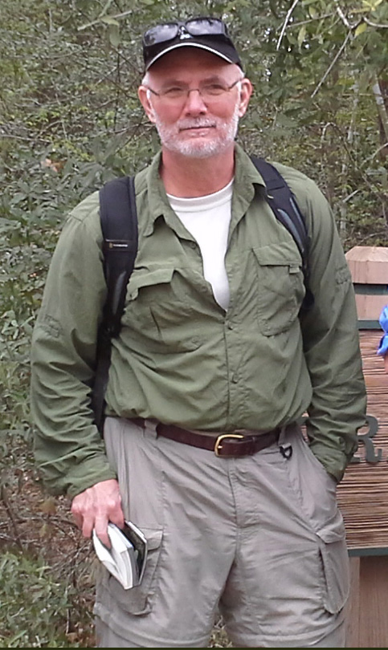**Nematodes**

**Taxonomic Working Inventory Group**

In December 2012 and March 2013, Southeast Texas was honored to have nematologists from the Universities of Nebraska and Tennessee come to collect samples as part of the Thicket of Diversity All Taxa Biodiversity Inventory. The researchers were attracted to Big Thicket by the variety of plant communities that live in close proximity within the preserve.

“We’ve heard about Big Thicket serving as a biological “crossroads” for plants, and we’d like to determine if it also serves as a crossroads for below ground organisms,” said Dr. Tom Powers, Research Leader, from the University of Nebraska group.

Thicket of Diversity Director, Mona Halvorsen of Saratoga, led the nematologists and nematology students through the different management units of the Big Thicket National Preserve where they took soil cores, recorded site data, and bagged soil for the return trip to the university laboratories.

Once back in the laboratory, the nematodes will be extracted from the soil, measured, photographed, and subjected to DNA barcoding. “DNA barcoding allows us to get a precise nematode identification and also lets us examine relationships between Big Thicket nematodes and those in similar plant communities outside the preserve,” said Powers.

Images and nematode descriptions will be posted by Halvorsen on the Big Thicket Association’s Thicket of Diversity web site once they are analyzed. [www.thicketofdiversity](http://www.thicketofdiversity).

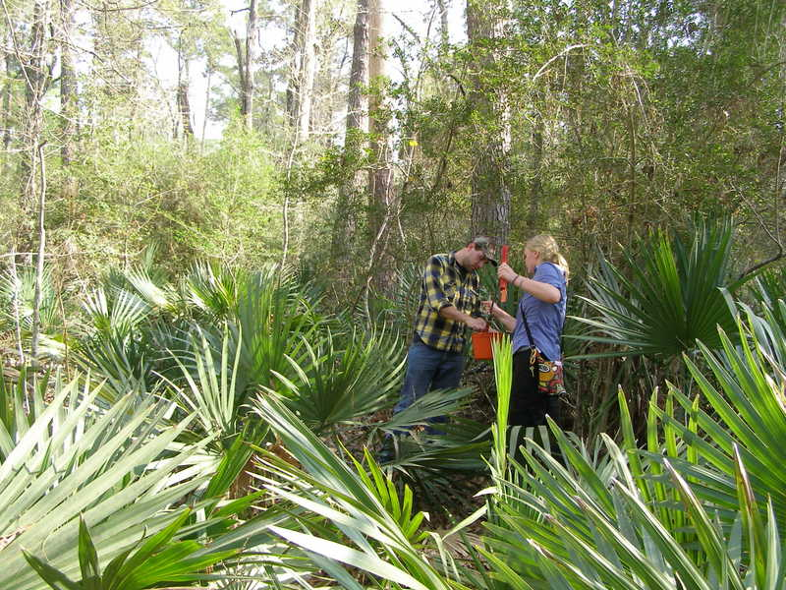

**Collecting Samples**

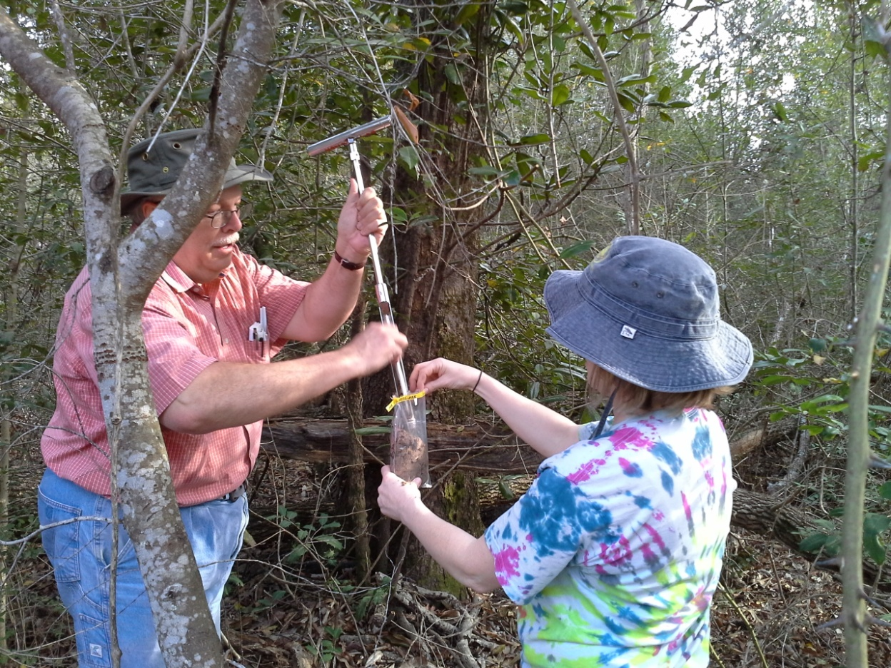

**Roundworms 101**

As one explores the natural world, the simplest life forms can yield information that both fascinates and terrifies. Nematodes, or roundworms, for example, outnumber most other species. They are second only to insects in the animal kingdom. It is estimated that 1 to 5 million species exist on this planet. The ocean floor is covered with nematodes, even the deepest trenches. Some people feel that nematode species diversity will probably outstrip insect diversity, in part because many insect species have associated nematode parasites. Only about 28,000 have been described of which 16,000 have been labeled as parasitic. The field is wide open to further investigation as many questions remain unanswered.

The group Nematoidea was originally described in 1808 by Karl Rodolphi; reclassified as a family Nematodes by Burmeister in 1837, and as order Nematoda by Diesing in 1861. There are a number of different classifications currently in use. Today most people consider Nematoda a phylum. It may also be listed as Nemata. Nathan Cobb (1859-1932) is known as “the Father of Nematology in the United States” as he provided the foundation for nematode taxonomy and described 1000 different species.

In 1914 Cobb eerily stated, “In short, if all the matter in the universe except the nematodes were swept away, our world would still be dimly recognizable…. We should find its mountains, hills, valleys, rivers, lakes and oceans represented by a film of nematodes. The location of towns would be decipherable, since for every massing of human beings there would be a corresponding massing of certain nematodes. Trees would still stand in ghostly rows representing our streets and highways. The location of various plants and animals would still be decipherable, and, had we sufficient knowledge, in many cases even their species could be determined by an examination of their erstwhile nematode parasites.”

Nematodes have successfully adapted to nearly every ecosystem from marine to freshwater, to soils from the polar regions to the tropics, as well as from the highest to the lowest of elevations. Nematodes on board NASA’s fateful Columbia space shuttle even survived the explosive disaster. They were recovered live from the wreckage. Scientist Nathaniel Szewcyk commented, “From an astrobiology standpoint, the important thing was that if you had a multicellular organism going through the atmosphere you can have interplanetary transfer of life by natural means, and Columbia demonstrated that.”

Nematodes are slender worms. The smallest are microscopic while free-living species can reach 5 cm (2 inches) in size and some parasitic species have been documented at over 8 meters in length. The body is often ornamented with ridges or bristles. The oral cavity is also strengthened with ridges or other structures and may even bear teeth, especially if carnivorous. The mouth often includes a sharp stylet which the animal can thrust into its prey. The oral cavity opens into a muscular sucking pharynx. Digestive glands are found in the gut to produce enzymes that break down food. In stylet bearing species these enzymes may be injected into the prey to hasten the process. Nitrogenous waste is excreted in the form of ammonium through the body wall. Salt is also excreted to maintain osmoregulation, the process that keeps the amount of waste and dissolved solutes in balance.

Nematodes play a major role in decomposition as they essentially turn bacteria and fungi into plant food. They are important in mineralizing, or releasing, nutrients in plant- available forms. They may control the balance between bacteria and fungi and the species composition of the microbial community. They control disease and cycle nutrients.

According to Elaine Ingram, free-living nematodes can be divided into four broad categories. Bacterial- feeders consume bacteria. Fungal feeders feed by puncturing the cell wall of the fungi and sucking out internal contents. Predatory nematodes eat all types of nematodes and protozoa. Omnivores eat a variety of organisms and may have a different diet at each life stage.

Foliar nematodes attack unwanted garden insects. They eat more than 400 varieties of borers, caterpillars and insect root pests. They help kill root weevils, cutworms, cabbage root maggots, lawn grubs, turf webworms, peach tree borers and flea beetle larvae. Some juvenile nematodes can enter the bodies of insects and infect them with bacteria. It kills them within 24 to 48 hours. Nematodes are often used as a biological control agent to manage other insect species. As they occur naturally they do not need to be registered by the EPA, and, as of 2010, there is no evidence that beneficial nematodes infect vertebrae species.

The types of nematodes present can indicate that the soil and growing crop are sick or in a healthy biological state. Agricultural soils often build up high levels of certain plant parasitic species, especially when the same crop species is grown continuously. That is why crop rotations are an effective nematode management tool. According to U.S. Ag, LLC, a nature friendly agriculture company, they can also be controlled by stopping the use of salty fertilizers to restore the soil to a natural sodium level and to use natural practices of incorporating green manures or composted animal manures into the soil. In other areas, high nematode levels are indicators of productive soils. Native prairies, for example, can contain high nematode levels with no evidence of a negative impact on plant growth in those systems.

A small fraction of all nematode species are parasites of humans, livestock or agricultural crops. Consequently, these have attracted the most attention from nematology researchers. Recent data have demonstrated that approximately 60 species of roundworms parasitize humans. Intestinal roundworm infections constitute the largest group of helminthic diseases in humans. According to a 2005 report by the World Health Organization approximately 0.807-1.221 billion humans have ascariasis, 604-795 million have trichuriasis, and 576-740 million have hookworm infections worldwide. Well known animal parasites with health and economic impact include pinworms, hookworms, trichina and dog heartworm. Some nematodes are pests of a wide variety of crops. The US Department of Agriculture estimated a $5 to $8 billion a year crop loss to U.S. growers from nematodes and nearly $100 billion loss worldwide. It is evident that effective, economical, ecologically based management of nematodes is a key component of future food and fiber production. Further research is needed as enhanced understanding of nematode biodiversity will contribute to sustainable agriculture and improve the quality of life in an ever increasing world population.

**Nematode TWIG 2013**

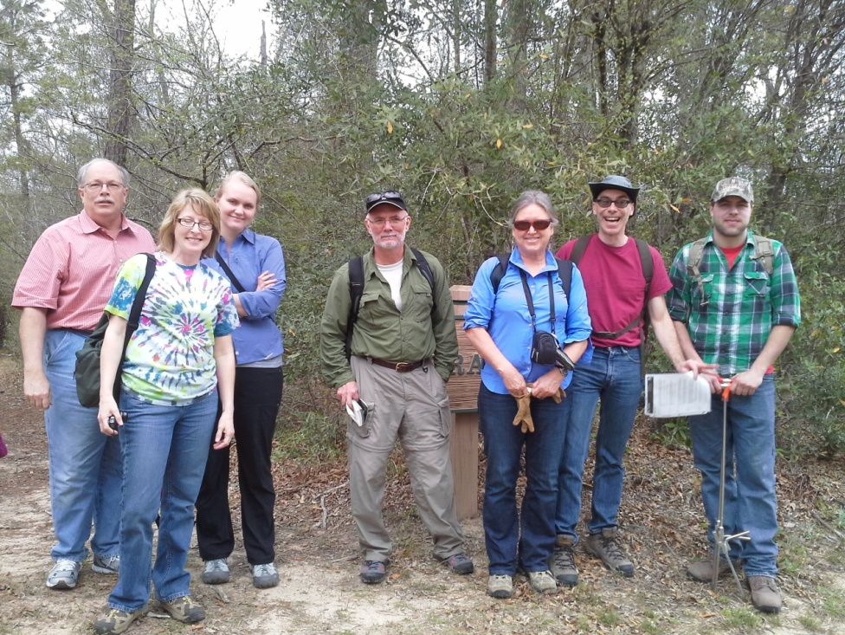

Dr. Ernest Bernard, Kim Whitlock, Maggie Olson, Dr. Tom Powers, Kris Powers, Dr. Peter Mullin, Matt Lodema (Kim, Maggie, and Matt are students.)

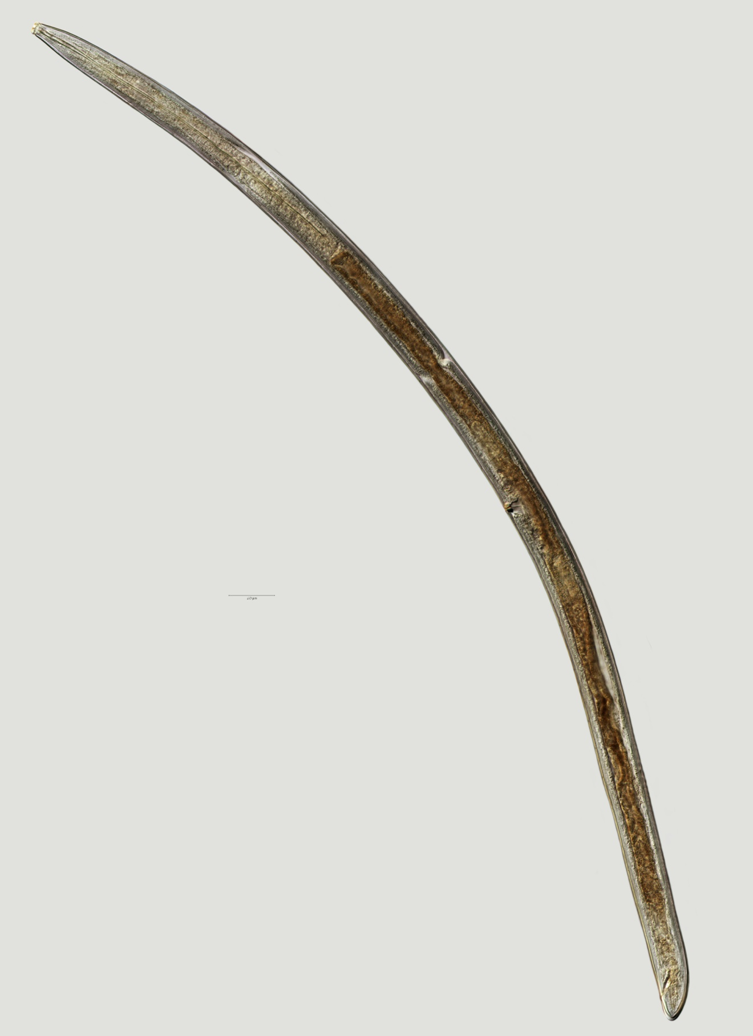

 The ***Aporcelaimellus obtusicadatus*** is a predator.

It has a different form of stylet that is used to pierce other nematodes.

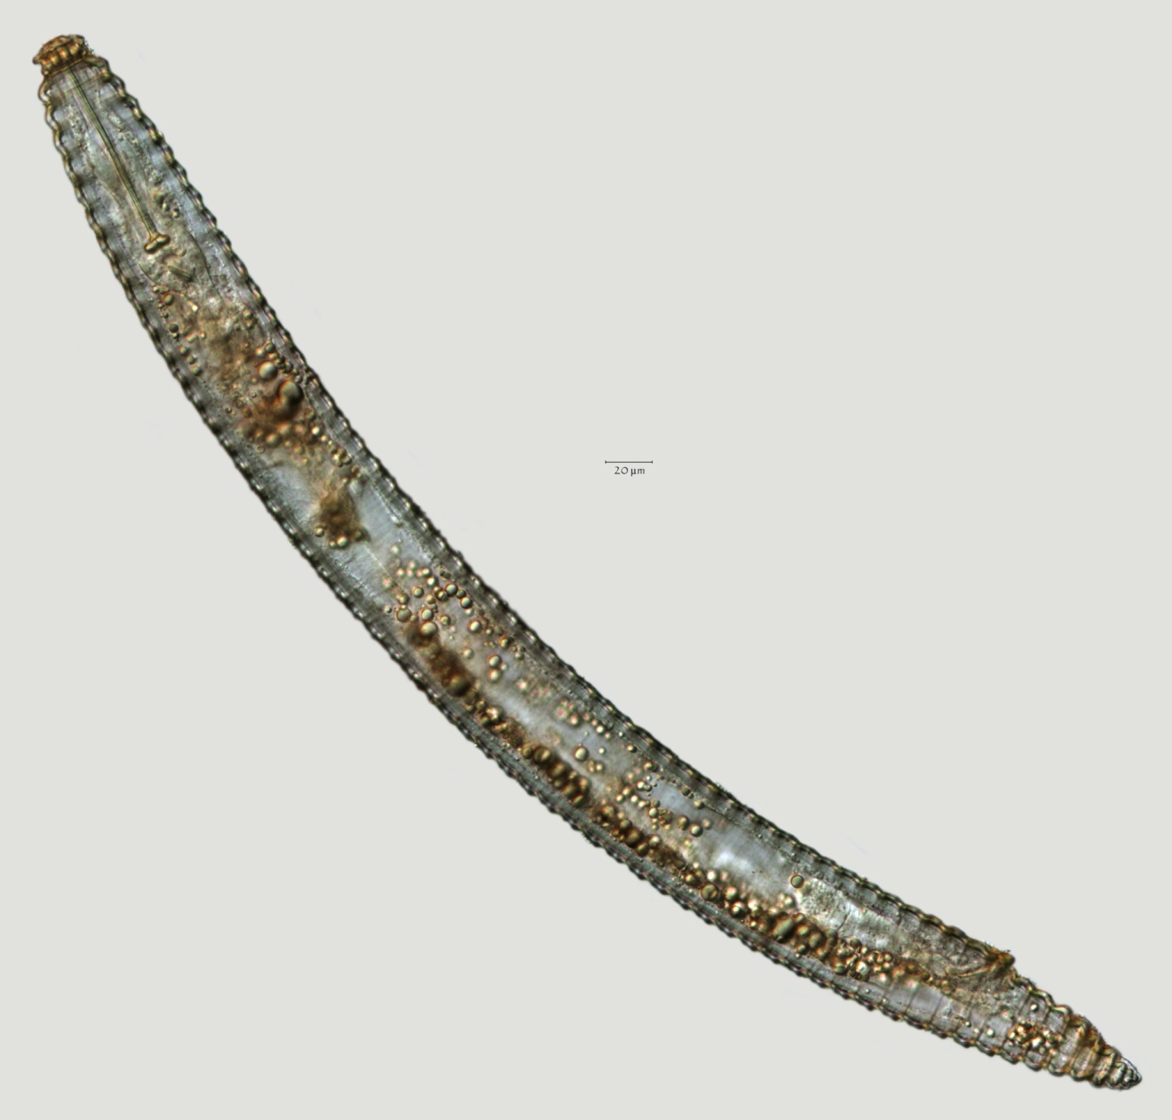

***Criconema annuliferum***

Criconema species is a plant parasite.

It is recognized by the needle like stylet that it has at the head end.

The stylet is inserted into plant roots to extract cell contents.

Report written by Mary C. Johnston

Photos by Mona Halvorsen

Nematodes images provided by Dr. Powers from samples from the Jack Gore Baygall Unit of the Big Thicket National Preserve

**References**

# Barker, K., Hussey R., & Krusberg L. (1994). Plant & Soil Nematodes: Societal Impact and Focus for the Future. *Journal of Nematology*, 26, 127-137, Retrieved from <http://www.ncbi.nlm.nih.gov/pmc/articles/PMC2619488/pdf/127.pdf>

Hökelek, M. Nematode Infections. Retrieved from Medscape Reference Drugs, Diseases & Procedures website: <http://emedicine.medscape.com/article/224011-overview>

Having Nematode problems yet? Retrieved from U.S.Ag, LLC website: http://unitedstatesag.org/nematodes.

Ingham, E. Chapter 6: NEMATODES. *Soil Biology*. United States Department of Agriculture, Natural Resources Conservation Service. Retrieved from <http://soils.usda.gov/sqi/concepts/soil_biology/nematodes.html>

Kramer, M. (2013, January 30). How worms survived NASA’s Columbia Shuttle Disaster. SPACE.com. Retrieved from <http://www.space.com/19538-columbia-shuttle-disaster-worms-survive.html>

Nematode. Wikipedia: Retrieved from <http://en.wikipedia.org/wiki/Nematode>

PPT- Nematode Powerpoint Presentation/ Free to View. Plant Pathology at the University of Wisconsin- Madison. Retrieved from <http://www.powershow.com/view/162952-M2U5N/Oct_1216_Nematodes_powerpoint_ppt_presentation>

What are Nematodes, Retrieved from Department of Nematology, University of California Riverside website: <http://nematology.ucr.edu/nematodes.html>

What are Nematodes, Retrieved from University of Nebraska- Lincoln, Nematology website: <http://nematode.unl.edu/wormgen.htm>