Project Title: Surveys of freshwater mussels in 9 units of the Big Thicket Preserve

Project Leader
Dr. Neil B. Ford
Department of Biology
3900 Univ. Blvd
University of Texas at Tyler
Tyler, TX 75799
(903) 566-7249
nford@mail.uttyl.edu

Coordinating Organization:
University of Texas at Tyler
Debbie Gibson, Associate Director
Post Award, Office of Sponsored Research
The University of Texas at Tyler
3900 University Boulevard
Tyler, Texas 75799
(903) 565-5903
dgibson@uttyler.edu

Species Affected: Unionid mussels

Introduction

Freshwater mussels (order Unionoida) as a group are considered one of the most imperiled taxa in North America (Brogan, 1993; Haag and Williams, 2014). Almost 70% are imperiled or threatened to some degree (Haag, 2012). In Texas, 15 of the 52 species are listed as State Threatened (Burlakova et al., 2011). Six of those are found in the Big Thicket National Preserve (BTNP) including Fusconaia askewi (Texas Pigtoe), F. lananensis (Triangle Pigtoe), Lampsilis satura (Sandbank Pocketbook), Obovaria arkansasensis (Southern Hickorynut), Pleurobema riddellii (Louisiana Pigtoe), and Potamilus amphichaenus (Texas Heelsplitter). It should be noted that O. arkansasensis was, until recently, recognized as Obovaria jacksoniana (Howells 2014, Inoue et al. 2013). Mussels historically were the dominant biomass in aquatic ecosystems occurring in dense multispecies beds that were important in removing suspended organic material, moving sediment and providing food and habitat for other organisms (Strayer, 2008; Atkinson et al., 2011). The declines in their numbers relates to a number of factors including a sedentary lifestyle and a long life in addition to requiring host fish for the parasitic young (Vaughn, 2010; Haag, 2012). Overharvesting, pollution, the building of reservoirs and other human activities have been implicated in the dramatic lost of mussels throughout the world.

East Texas has over 35 species of unionid mussels in several river drainage basins (Howells, et al., 1996). The factors that impact mussels in other areas of North America are evident in Texas too, particularly east Texas. Reservoirs and smaller impoundments are plentiful, erosion from agriculture and pollution from Oil and gas activities are known to impact the aquatic ecosystems of east Texas. The lower Neches and Trinity Rivers have an extensive history of anthropogenic impacts including channelization, dredging and pollution (Harrel and Hall, 1991; Harrel and Smith, 2002). Reduced flows from upstream have also increased saltwater intrusion. However, recently the Neches and its tributaries above Beaumont have received some environmental protection as they run through the lands of the Big Thicket National Preserve. In addition, a saltwater barrier dam now helps lower saltwater encroachment. When the Big Thicket National Preserve was founded in 1974 the majority of the Neches River south of B. A. Steinhagen Reservoir was protected along with some riparian habitat along the river (Tyler et al., 1996). Whether mussel diversity and abundance have received improvement from the presence of the preserve is not known, as mussel surveys for the area are limited and dated. The most recent unionid surveys for the lower Neches River Basin within the Big Thicket National Preserve were conducted in the 1990s and for Village Creek in 2002 (Bordelon and Harrel, 2004; Feaster, 1996; Howells, 1997). These surveys had relatively few records of rare species.

In the summer of 2013 with the help of a Thicket of Diversity grant, I surveyed the upper units of the Big Thicket National Preserve (Figure 1. Beech Creek, Upper Neches River Corridor, Canyonlands and the Neches Bottom and Jack Gore Baygall Units). We recorded 564 live and 313 dead mussels of 23 species from 30 sites. The current report from a 2014 TOD grant extends the surveys to the 9 lower units including the Lower Neches River Corridor, the Beaumont unit, Village Creek, Lance Rosier, Little Pine Island, Pine Island Bayou corridor, Big Sandy Creek and Corridor, Turkey Creek and Menard Creek Corridor units (Figure 2). I am combining that data with the previous surveys to produce a document of mussel occurrence in all the units of the BTNP.

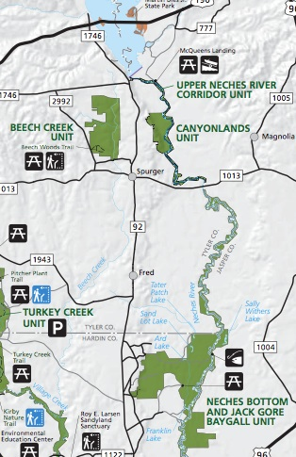

Figure 1. Upper Units of the Big Thicket National Preserve that were surveyed in the summer of 2013.

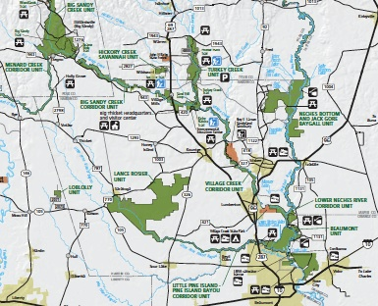

Figure 2. Nine units of the Big Thicket National Preserve surveyed in the summer of 2014.

Methodology

From May 2013 to September 2014 a total of 72 surveys were conducted throughout the BTNP and surrounding areas (Figure 3). Access to field sites was by kayak or boat from the nearest road or trail. Each survey consisted of at least one person/hour of search time on the bank and in the water body of a length of 50 to 100 meters. Tactile searches were conducted in the substrate in all habitat types, i.e. riffles, pools and runs when those habitats were available. This informal search method is known to produce accurate relative abundance data and in particular is valuable to locate rare species (Strayer and Smith, 2003). After collection all specimens were identified, counted and returned to the water. Vouchers were made from recent dead specimens and deposited in The University of Texas at Tyler invertebrate collection. Survey sites were georeferenced and notes made on length of stream and substrate. A table summarizing the number of live mussels of each species found in each BTNP unit is given as Appendix 1. For this table, sites where mussel surveys were performed were placed within the nearest unit if they were outside a BTNP unit.

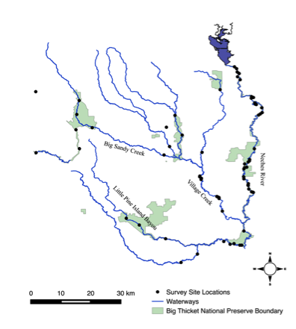

Figure 3. Location of surveys conducted in the Big Thicket National Preserve in the summers of 2013 and 2014. Note the isolated dot in the upper left is from a small creek that was not present on GIS maps.

Objectives

The overall goal of these two projects was to determine current occurrence of unionid mussels in all the units of the Big Thicket National Preserve. In addition, abundance data for all species including the State Threatened species were gathered. These records will help determine areas of the PTNP where mussels are abundant and may give insight into what future conservation work may be needed for rare species.

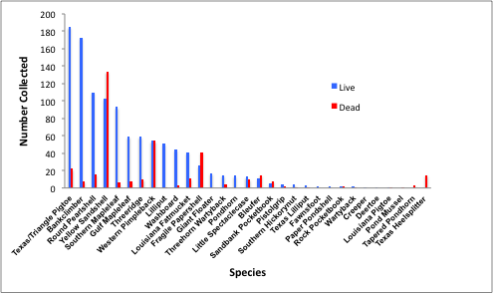
Figure 4. Relative abundance of unionid mussels collected in 2013 and 2014 in the units of the Big Thicket National Preserve ranked by the number found live for each species from most to least abundant. The State threatened Texas Pigtoe and Triangle Pigtoe are not distinguishable from external morphology and so were grouped together.

1535 live mussels from 28 species were collected during 72 surveys in the summers of 2013 and 2014 (Figure 4). The State threatened Texas Pigtoe and Triangle Pigtoe are not distinguishable from external morphology and so were grouped together. These pigtoes were both the most abundant mussels found but were not found in every site (Figure 5). Although both species are protected in the State, the Triangle Pigtoe has a much more limited range and is currently found only in the Angelina River, Attoyac Bayou and the Village Creek area in the BTNP. Until morphological differences are more clearly established protecting the more abundant Texas Pigtoe is also necessary. The Bankclimber was the next most common mussel species. It occurs in backwater habitats and along with other slackwater species like the Louisiana Fatmucket, Little Spectaclecase, Texas Lilliput and Tapered Pondhorn can deal with the low oxygen and hot temperatures in the shallow creeks that occur during the summer. These species were therefore found in the BTNP units with small streams such as Beech creek, Turkey creek, Lance Rosier, Hickory creek, and Menard creek. Big Sandy Creek unit contains the headwaters of Big Sandy Creek so it also only had these backwater species although it was the only one of the small creeks that had Texas Pigtoe. Texas Pigtoe was also found in Menard creek, a tributary of the Trinity River, even though this small creek only had 3 species of mussel. Of the small creeks, Beech Creek had the most species with 5 including the large river species, the Yellow Sandshell. Hickory creek had no mussels, as it was a very ephemeral water body.

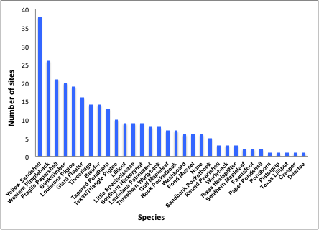
Figure 6. Number of sites where each species of mussel was found during surveys in the Big Thicket National Preserve in 2013 and 2014.

The units with larger streams all had more mussel species. Canyonlands and upper Neches corridor had 13 species, Jack Gore Baygall had 16 species, Lower Neches Corridor had 17 species, Beaumont unit had 11 species, Village creek with 22 species found live and Little Pine Island Bayou with 8 species. Canyonland and Upper Neches Corridor unit was heavily impacted by the variable and often high flows from B. A. Steinhagen reservoir. This dam is a hydroelectric power generator and so has very high summer flow reaching 20,000 cfs. The main stem of the Neches River there consists of shifting sands that is unsuitable for most species of mussel. The Yellow Sandshell and the Western Pimpleback are two species that are fairly mobile and so were able to live in sandy areas so occurred in the most sites. The greater diversity of mussels in the Neches River occurred back in oxbows and tributaries, which provided some refuge from the scouring effects of the high flows (Strayer, 1999). Therefore, the Jack Gore Baygall unit had more species of mussels primarily because it contains a number of oxbows and tributaries off the main stem of the Neches River. In several of these backwaters the number of mussels was quite high and so this particular unit is one of the most valuable in terms of protection for mussels in the upper portion of the BTNP. The Lower Neches Corridor is a meandering slow moving river and the variable flows from the dam are less dramatic in this unit. It contained 17 species in good numbers with some rare species such as Fawnsfoot and the threatened Louisiana pigtoe and Sandbank pocketbook. This unit and the Beaumont unit, which had 11 species were the most difficult to survey as access points were far apart and the river was also deep in these sections. Scuba divers will be required to improve additional information about the mussels in these two units. Village creek is known to have a diverse mussel fauna (Bordelon and Harrel, 2004) and we collected 22 species and also the most mussels total. It also included 4 threatened species and was the only location with Southern Hickorynut. That species is only found at Village Creek and a small area in the upper Neches. It had not been recorded at Village creek for a number of years so apparently is persisting but in low numbers. The continued monitoring of this unit’s mussel fauna is warranted. The lower number of species in Little Pine Island Bayou (8 species) was unexpected. Neither threatened nor other rare species were recorded there although the habitat appeared suitable. Perhaps the proximity to Beaumont is impacting this water body.

State Threatened species

Texas Pigtoe and Triangle Pigtoe were found in abundance at several of the sites in the lower units of the BTNP. However, since the two species can not be identified from external morphology, conclusions about the abundance of the more rare Triangle Pigtoe can not be made. The Louisiana Pigtoe was extremely rare and only one was found in the Lower Neches River Corridor unit. Continued surveying for this species is warranted since it is much more abundant in the Neches River above B. A. Steinhagen reservoir. Southern Hickorynuts were found in Village Creek but not in abundance. That species is rare throughout the state and this unit is one of only two areas where it is known to occur. Sandbank Pocketbooks were not common but were found in the larger streams, i.e. in the Upper and Lower Neches River corridor units. Texas Heelsplitters were also found in the sandbanks of those sections but only dead were recorded. All these state threatened species are rare in the BTNP units and they should be continued to be monitored.

Conclusions

The Big Thicket National Preserve is a group of protected units connected by corridors of small to large streams. The units vary in size from small (Loblolly) to large (Lance Rosier) and therefore some contain waterbodies and others do not. The small streams in the units have a depauperate mussel fauna as only a few species of mussel can tolerate the high temperatures and low oxygen in such streams during summer fragmentation. The larger streams that go though a few units have more species and overall contain most of the unionid mussel species that would be expected in southeast Texas. However, the number of live mussels recorded in the surveys in the BTNP was low compared to areas in the Neches River above B. A. Steinhagen reservoir (Ford, 2013). The substrate in the mainstem of the Neches River from below the dam down to the Beaumont unit consists of shifting sands created by the high flow. High currents have eroded the banks there and only a few gravel bars that support mussels remain. Only mobile species like Yellow Sandshell, Western Pimpleback and Bleufer, and thin-shelled species like Fragile papershell do well in shifting sand. We did find some of the threatened Sandbank Pocketbooks, which is also mobile and the Texas Heelsplitter, which is thin-shelled. Canyonlands and Jack Gore Baygall units have numerous oxbows and tributaries that are refuges from the high shear stresses during high water release from the dam. These backwater areas had higher abundances of mussels and protecting those units containing those oxbows will be important for mussels.

The streams that join the lower Neches River contained good diversity and some reasonable numbers of mussels. Village creek in particular has a diverse mussel fauna. The very rare southern Hickorynut was only found there and so this stream is critical for that species as it is only found in one other location in the upper Neches River. Pine Island Bayou, Big Sandy creek and Turkey creek are also important streams in terms of overall diversity of the mussels of the BTNP. Surveys in these units were only near bridge access points and so potentially more sites between bridges contain additional mussel beds. Protecting the corridors between units will help protect these important organisms.

In conclusion, the unionid mussel populations in the Big Thicket National Preserve were evaluated in the summers of 2013 and 2014 with mixed results. Although overall diversity was good, very few areas had large populations of mussels. In particular, the mainstem of the Neches River where it passed through several units had low mussel abundances. Smaller streams in units also had low mussel diversity but that is a normal situation for headwaters. Backwater areas found in some of the units such as Canyonlands and Jack Gore Baygall and the mid-sized streams off the Neches River did have significant numbers of mussels and often contained rare species. Although many of the BTNP units did not contain streams large enough to support big river species, the corridor units often did. Protecting more land around corridors and adding additional river corridors between units would be a good approach to improving conditions for mussels here. Additional monitoring in areas of more diversity is also recommended. It is unlikely that any moderation of the high and variable flows from B. A. Steinhagen reservoir will occur so the upper mainstem of the Neches River will remain poor habitat for mussels.

Literature Cited

Atkinson, C. L., M. R. First, A. P. Covich, S. P. Opsahl, S. W. Golladay. (2011). Suspended material availability and filtration-biodeposition processes performed by a native and invasive bivalve species in streams. Hydrobiologia, 667:191-204.

Bogan, A.E. (1993). Freshwater bivalve extinctions (Mollusca: Unionoida): a search for causes. American Zoologist, 33(6):599-609.

Bordelon, V.L., and R.C. Harrel (2004). Freshwater mussels (Bivalvia: Unionidae) of the Village Creek drainage basin in southeast Texas. Texas Journal of Science, 56(1):63-72.

Burlakova, L.E., A.Y. Karatayev, V.A. Karatayev, M.E. May, D.L. Bennett, and M.J. Cook (2011). Biogeography and conservation of freshwater mussels (Bivalvia: Unionidae) in Texas: Patterns of diversity and threats. Diversity and Distributions, 17(3):393-407.

Feaster, D.M. (1996). A survey of the freshwater mussels of the lower Neches River basin, Texas (Masters Thesis). Stephen F. Austin State University, Nacogdoches, TX.
Ford, D.F. (2013). Ground-Truthing Maxent in East Texas Rivers (Masters Thesis). University of Texas at Tyler, Tyler, TX.

Haag, W.R. (2012). North American Freshwater Mussels: Natural History, Ecology, and Conservation. Cambridge University Press.

Haag, W.R., and J.D. Williams (2014). Biodiversity on the brink: An assessment of conservation strategies for North American freshwater mussels. Hydrobiologia, 735(1):45-60.

Harrel, R.C., and S.T. Smith (2002). Macrobenthic community structure before, during, and after implementation of the Clean Water Act in the Neches River estuary (Texas). Hydrobiologia, 474(1-3):213-222.

Harrel, R.C. and M.A. Hall (1991). Macrobenthic community structure before and after pollution abatement in the Neches River estuary (Texas). Hydrobiologia 211:241-252.

Howells, R. G., R. W. Neck and H. D. Murray. 1996. Freshwater mussels of Texas. Texas Parks and Wildlife Press, Austin, Texas.

Howells, R.G. (1997). Status of freshwater mussels (Bivalvia: Unionidae) of the Big Thicket region of eastern Texas. Texas Journal of Science, 49:21-34.

Howells, R.G. (2014). Field Guide to Texas Freshwater Mussels. Biostudies, Kerrville, Texas.

Inoue, K., D.M. Hayes, J.L. Harris, and A.D. Christian (2013). Phylogenetic and morphometric analyses reveal ecophenotypic plasticity in freshwater mussels Obovaria arkansasensis and Villosa arkansasensis (Bivalvia: Unionidae). Ecology and evolution, 3(8):2670-2683.

Strayer, D.L. (1999). Use of flow refuges by unionid mussels in rivers. Journal of the North American Benthological Society:468-476.

Strayer, D.L., and D.R. Smith (2003). A Guide to Sampling Freshwater Mussel Populations (No. 8). Bethesda, Maryland: American Fisheries Society.

Strayer, D. L. (2008). Freshwater Mussel Ecology: A Multifactor Approach to Distribution and Abundane. Univ. Cal. Press. 216 pp.

Tyler, R.C., D.E. Barnett, and R.R. Barkley, (1996). The new handbook of Texas (Vol. 2). Texas State Historical Association.

Vaughn, Caryn C. 2010. Biodiversity losses and ecosystem function in freshwaters: emerging conclusions and research directions. BioScience 60:25-35.

