Dr. Larissa N. Vassiljeva
15 Feb 1950 – 23 Feb 2017
Russian mycologist, amazing collector and specialist in Pyrenomycetes.

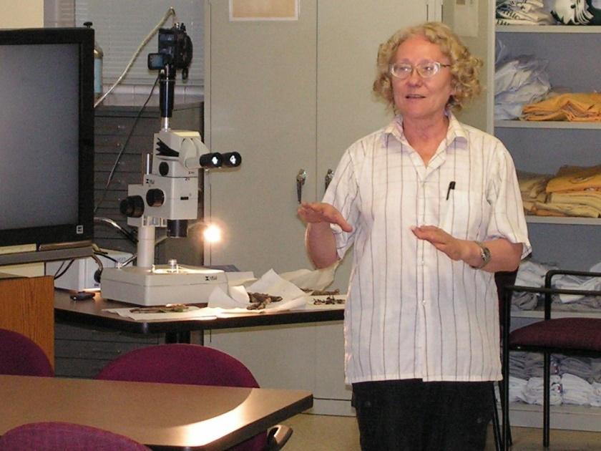
Dr. Larissa Vassiljeva at Big Thicket Field Research Station, Saratoga
Larissa N. Vassiljeva (1950-2017) loved to collect fungi, wandering through the woods humming softly to herself. She specialized in very small ascomycetes partly, perhaps, because she had myopia or near-sightedness that allowed her to see clearly the small black dots of pyrenomycetes scattered along a dead branch. She would pick up a likely substrate, pull off her thick-lensed glasses and examine the stick without a hand lens because, basically, she had a “built-in” hand lens for eyes. In addition, she had a sense of the biology of these fungi and thus knew where to look for them. She was fearless in her ability to endure hot and cold weather in search of her beloved pyrenomycetes.
The study of pyrenomycetous fungi in Texas has been limited. Two papers under the same title The Fungi of Texas by M.C. Cooke in 1879 and 1880 were published. 33 species of the fungi were reported, mostly in the Houston vicinity. 100 years later, only three were found in Texas as noted by E.P. Van Arsdel in 1972. Dr. Vassiljeva’s lifetime of work significantly contributed to existing knowledge of fungi through her discoveries of new species to science.
Dr. Larissa Vassiljeva traveled to the Big Thicket of Texas to research. She made three trips as a lead investigator with the Big Thicket Association’s Thicket of Diversity (ToD), an All Taxa Biodiversity Inventory, coordinated through a partnership between the Big Thicket National Preserve. Through the ToD, she conducted surveys in the preserve in 2007, 2009 and 2011. Vassiljeva’s Annual Reports for Permit filed her findings. At present 65 species of Pyrenomycetous fungi have been identified. Other findings include rare species such as Rosellinia glandiformis found in Turkey Creek Unit and Rosellinia langloisii in Lance Rosier Unit and Jumillera viridis found in Canyonlands Unit of the Big Thicket National Preserve. The first record in the USA of Hypoxylon lividipigmentum was found on the Kirby Nature Trail outside Kountze. Another first for USA was Biscogniauxia arima found in the Lance Rosier Unit in Saratoga. Previously, both were found in Mexico.
Dr. Larissa Vassiljeva has identified some specimens collected by David Lewis, a renowned mushroom researcher and President of the Gulf States Mycological Society, in other parts of Texas. The discovery of Biscogniauxia citriformis suggested a peculiar biogeographical pattern of distribution that involves the Caribbean Sea, the coast of Mexico and southern US as well as some parts of the Atlantic coasts in South America and Africa. The species was found in Nigeria and French Guiana.
Dr. Larissa N. Vassiljeva was born in Kursk in western Russia. From 1967-1972 she was a student specializing in mycology at Leningrad State University. In Soviet times students were placed on a job after graduation and they could choose where they would like their future job. Larissa chose the Russian Far East because this region was especially interesting for mycological investigation. Since August 1972 she worked at Institute of Biology and Soil Science in Vladivostok, Siberia, as a scientific researcher and since 2002 she was regarded as a principal researcher.
For about ten years she studied fungi of the Magadan Region, Kamchatka and Chukotka. The results of these investigation were published in her first book Pyrenomycetes and loculoascomycetes of the North of Russian Far-East (1987). For this work and others, she received the “Doktor nauk”, Doctor of Sciences, in 1992.
Pyrenomycetous fungi inhabit living and dead tissues of vascular plants and are very often found on bark and wood of trees. They are the organisms that serve the function of popping off the bark so the wood on the forest floor can decay. Each group of fungal species prefers wood that has decayed for a different amount of time. Some prefer recently dead trees. Other fungal species go for very rotten wood.

Vassiljeva was an officer in the International Mycological Association Committee for Asia (1995-2002), a member of the Mycological Society of Japan (since 1995), a member of the Mycological Society of America (since 1997), and a member of the Russian Academy of Sciences.
Pyrenomyceteous fungi play an important role in decomposition as they facilitate the return of nutrients to the soil. Larissa, the mycologist, identified many interesting and unusual microfungal specimens that she willingly shared with others while theorizing her unconventional ideas about relationships among these fungi. Research conducted by experts such as Dr. Vassiljeva contributes to knowledge of diversity within this species and is appreciated and valued. She will be greatly missed.
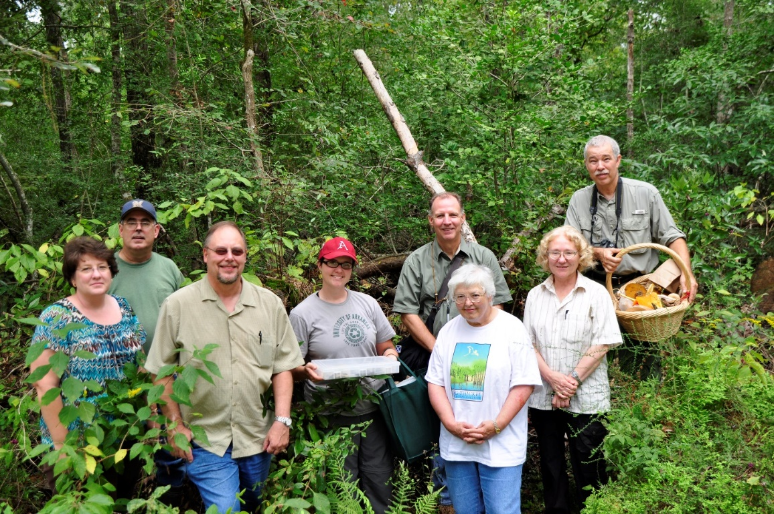
Melinda Barnes- Texas Master Naturalists; John Glen Soileau and Kevin Barnes- Gulf States Mycological Society; Katherine Winsett- University of Arkansas; Dale Kruse- Tracy Herbarium Texas A&M; Pauline Singleton- Watson Rare Native Plant Reserve; Larrissa Vassiljeva- Far East Branch of Russian Academy of Science; David Lewis- Gulf States Mycological Society, 2009
Pyrenomycetous Fungi New species of (Ascomycota)
Discovered in Big Thicket region by Larissa Vasilyeva, PhD; Far East Branch of the Russian Academy of Sciences through the Thicket of Diversity:
Jumillera viridis, found in Canyonlands Unit of Big Thicket National Preserve
Diatrype caryae, Authors: Lar.N. Vassiljeva & S.L. Stephenson, Mycotaxon 107: 309 (2009) Host-Substratum/Locality: On dead branches of Carya tomentosa (mockernut hickory): Texas
Diatrype ilicina, Authors: Lar.N. Vassiljeva & S.L. Stephenson, Mycotaxon 107: 311 (2009) Host-Substratum/Locality: On dead branches of Ilex vomitoria (Yaupon): Texas
Neochaetosphaerella thaxteriospora, Authors: Lar.N. Vassiljeva, S.L. Stephenson & Chernyshev, Fungal Diversity 52(1): 192 (2011)
Tympanopsis texensis, Authors: Lar.N. Vassiljeva, S.L. Stephenson & Chernyshev, Fungal Diversity 52(1): 191- 196 (2011)
Hypoxylon rosieri, Authors: J.D. Rogers & Lar.N. Vassiljeva (Rogers et al., 2008; Vasilyeva & Stephenson, 2009). –Named after Lance Rosier
Camillea texensis, Authors: J.D. Rogers & Lar.N. Vassiljeva

Contributors:
Amy Rossman, Alexey Chernyshev, Steven Stephenson, Dale Kruse, Mary Catherine Johnston, Mona Halvorsen, David Lewis, Jason Ginder

