Project Title: FINAL REPORT
Freshwater mussel biodiversity status and evaluation of population response to catastrophic flooding within the Big Thicket National Preserve, Texas, 2017-2018

Primary Investigator:
Astrid Schwalb, Ph.D.
Assistant Professor
Department of Biology
Texas State University
San Marcos, TX
Schwalb@txstate.edu

Assisting Investigator:
Thom Hardy, Ph.D.
Professor and Chief Science Officer,
The Meadows Center for Water and the Environment
Texas State University
San Marcos, TX
Thom.Hardy@txstate.edu

Primary Contact:
Alison Tarter
Masters Candidate
Department of Aquatic Biology
Texas State University
San Marcos, TX
409-920-5889
TARTERA@ME.com

FAIR USE AND AUTHOR’S PERMISSION STATEMENT

Fair Use

This work is protected by the Copyright Laws of the United States (Public Law 94-553, section 107). Consistent with fair use as defined in the Copyright Laws, brief quotations from this material are allowed with proper acknowledgement. Use of this material for financial gain without the author’s express written permission is not allowed.

Duplicate Permission

As the copyright holder of this work I, Alison A. Tarter, authorize duplication of this work, in whole or in part, for educational or scholarly purposes only.

Introduction

The Big Thicket National Preserve (BTNP) is known as one of the most extraordinarily biodiverse regions in North America (Moring, 2003). Unfortunately, the BTNP is also recognized as the most at-risk of the “crown jewel” parks in the national parks system (Callicott et al., 2006). Concurrently, freshwater mussels (Bivalvia: Unionidae), valuable bio-indicators of overall ecosystem health and habitat quality (Bordelon and Harrel, 2004; Burlakova et al., 2011), are considered the most highly threatened and rapidly declining North American fauna (Karatayev and Burlakova, 2007; Vaughn and Taylor, 1999). The highest number of regional endemic unionid species in Texas occur in the waters of East and Southeast Texas where 6 of the 15 state-threatened species (STS) have been documented: Fusconaia askewi (Texas pigtoe); Fusconaia lananensis (Triangle pigtoe); Lampsilis satura (Sandbank pocketbook); Obovaria arkansasensis (Southern hickorynut); Pleurobema riddellii (Louisiana pigtoe); and Potamilus amphichaenus (Texas heelsplitter) (Howells, 2010). Basic data on the life history traits and population dynamics is lacking or unknown for all six species. In addition, taxonomy is unclear for multiple unionid species of conservation concern (Plants-Paris, 2016). The Neches River basin is noted to be the “hot spot” of Texas unionid diversity (Burlakova et al., 2011). The upper units of the BTNP were known to contain areas of exceptional mussel diversity (Howells,1997), and the lower Neches River, downstream from Town Bluff Dam (B. A. Steinhagen), was noted as recently as 2007 to hold the most abundant and diverse assemblage of mussels in Texas (Karatayev and Burlakova, 2007). Unfortunately, the upstream reaches of the larger streams that flow through the BTNP are heavily modified (Benke, 1990), and Ford (2015-Unpublished) reports that waters released at B. A. Steinhagen resulted in the loss of a large mussel bed formerly documented below the dam. He also states that habitat within the Upper Neches River Corridor unit no longer appears to support the historic diverse population of mussel species.
Presently, several factors have caused the biodiversity of mussel populations in the BTNP to be unknown. The first factor is the large amount of recent heavy precipitation events. In fact, high rainfall in 2016 caused the largest flood ever recorded in the region. Multiple USGS gauge stations in the region recorded the highest stream-flow velocities in more than 20 years. However, the high flows caused by the unprecedented precipitation during Hurricane Harvey in 2017 surpassed those on record to date. While stalled on land over the Big Thicket Ecoregion, Harvey inundated sections of Jefferson Co., TX, with >153.67 cm of rain, the most rainfall produced by any tropical cyclone in United States’ history (NOAA, 2018). Both high-flow events occurred after the completion of the last formal freshwater mussel surveys, performed by Ford et al. 2013-2014, in the BTNP region.
Second, poorly surveyed areas with biodiversity hotspots--areas where rare and/or endemic species are found in exceptional concentrations and where habitat alteration could lead to the rapid decline or eradication of such species--should be identified and frequently monitored for priority conservation efforts (Downing et al, 2010; Lydeard et al., 2004). While Ford (2015-Unpublished) notes that mussel diversity and abundance are highest in the backwater-type habitats of the BTNP region, with few exceptions, the selected survey sites were at easy access locations like bridges, leaving most of the more beneficial backwater mussel habitat un-checked. Therefore, increased studies of the backwater areas in the lower units of the BTNP are vital as such locations receive some protection from flow disturbances created by upstream dams and stream modification; this protection likely causes the numerous backwaters within the lower BTNP to be vital to mussel recruitment within the region. Although prior mussel surveys have been conducted in the BTNP region, none have specifically focused on such locations in the lower units.
Third, the current proposal to construct toll roads threatens the abundance and diversity of mussel species currently protected by the southern units of the BTNP. Though minimally surveyed, these far downstream locations which are upstream from the Lower Neches Valley Authority’s saltwater barrier (SWB) likely provide habitat suitable for rare, sensitive, and state-threatened mussel species.

Methodology
To locate unionid mussels in the waters of the Big Thicket ecoregion of Southeast / East Texas, we selected and surveyed areas with hydraulic characteristics beneficial to freshwater mussels, including areas not reached by and methods not used in past surveys. Sites were selected through a combination of analysis of past available data, examination of past flow patterns, evaluation of historic imagery, and in situ observations related to specific habitat requirements suitable to the life history needs of the state-threatened mussels. Access to sampling sites was made by motor boat, kayak, vehicle, and foot as conditions required.
A total of 52 survey trips in 7 units of the BTNP were completed for this project starting in August 2017 and continuing until July 2018. At each site a minimum of .25 person-hours was dedicated to detecting mussels by tactile searches. When mussels were detected, time was extended to at least one person-hour, depending on abundance and density. Sites were delineated by length and width, and searches were conducted from bank to opposite transect boundary for the length of the transect (usual 50 to 100M). Each site has been georeferenced and photographed.
In addition, total person-hours of search, length and width of transects, main channel width, average depth, habitat type/description, bank type, substrate composition, adjacent land use, anthropogenic influence, presence of exotic species, percent of shade, shore vegetation / aquatic vegetation, and flow charteristics have been recorded to allow for analysis of temporal change at each site. All specimens located were identified, counted, and returned to the stream. As possible, STS and other species of interest were photographed individually and measured (LxWxH). Non-lethal methods were used to obtain tissue samples for genetic analysis. When appropriate, dead individuals were retained to be stored at Texas State University for analysis or reference.

Objectives
The purpose of this project is three-fold: (1) to identify and document poorly surveyed areas of the BTNP, particularly in the southern portion of the preserve. This region contains numerous backwaters that are likely critical to mussel recruitment within the Thicket and can potentially provide refuge from high flow events; (2) to document the response of known mussel communities, like those in Village Creek, a recognized mussel sanctuary in need of continuous monitoring (Bordelon and Harrel, 2004; Karatayev and Burlakova, 2007), to the recent record flow events; and (3) through the collection and analysis of genetic material, to provide clarification on species status of unionids that cannot be distinguished by external morphology [like the STS F. askewi (Texas pigtoe) and F. lananensis (Triangle pigtoe); as such, pending DNA analysis results, they are counted as a single species, Fusconaia sp., in this report].

Results
Between August 20, 2017, and June 27, 2018, a total of 3596 (2902 live, 694 dead) individual unionid mussels from approximately 30 species (genetic analysis pending) were documented during 52 surveys of the waters of 7 units of the lower BTNP (Fig. 1). Results are compared with those of the 2013-2014 studies by Ford et al. (Fig. 2). In the present survey, living individuals from all regional STS were noted, including P. amphichaenus (Texas heelsplitter), a species not found live by Ford et al. in 2013-2014 (Fig. 3 and 4).
The Lower Neches River Corridor Unit (LNRCU) and the Beaumont Unit (BMT) were noted to have the highest density and number of living individuals, both with >1100 (Fig. 5 and 6).
With 1146 individuals from 22 species documented from just four sites, the LNRCU displays the highest density of unionids. Further, P. amphichaenus was documented at all four sites. All sites in this unit were in backwater-type habitats.
Fourteen sites were selected in the BMT unit with the majority representing backwater habitats. In this unit, 1249 live individuals from 22 species were noted, including STS P. amphichaenus and L. satura.
Twenty sites were selected in the Village Creek Corridor Unit (VCCU). A total of 375 individuals representing 22 different species were noted, including all regional STS but P. amphichaenus. The VCCU contained the highest diversity of living STS and was the only unit noted to contain O. arkansasensis and P. riddellii.
Four sites were selected in the Little Pine Island Pine Island Bayou Corridor Unit (LPIPIBCU). Forty-six individuals representing 9 species were documented. No STS were found in this unit.
Though just one site was selected in the Big Sandy Creek Corridor Unit (BSCCU), 55 individuals representing 5 species were documented, including 29 individual Fusconaia sp.
Four sites were selected in the Big Sandy Creek Unit (BSCU). Twenty-nine individuals representing 2 species were noted. No STS were detected.
One site in a large oxbow was surveyed in the Neches Bottom Jack Gore Baygall Unit (NBJGBU). Two individuals of separate species were found. No STS were detected (Fig. 7).

Discussion
Mussel distribution within a stream system tends to be “patchy” as mussel beds are most successful in areas where stream flow is high enough to impede the buildup of siltation yet low enough to provide bed stability. Sediment stability has been noted as the most vital habitat requirement for freshwater mussel beds. Unionid mussels have limited dispersal ability and experience limited refugia following natural or anthropogenic variation of stream flow (Vaughn and Taylor, 1999). In times of flow reduction, mussels are often stranded on dry land where they are exposed to terrestrial predation and desiccation (Bond et al., 2008). Conversely, the increased shear stress resulting from high-flow events, both natural and from water released from impoundments, causes stream bed components, including benthic fauna, to become dislodged and transported downstream. Mussel beds shift and are scoured by the dislodged material, which often includes other mussels. The small size and limited burrowing ability of juvenile unionids (usual found in the upper 8 cm of substrate) make them particularly susceptible to bed scour (Neves and Widlak, 1987; Vaughn and Taylor, 1999). After such events, it can take years for a population to reestablish numbers sufficient for continued successful recruitment and population stability (Karatayev and Burlakova, 2008).
Though little quantifiable data is available about the ecological effects of major natural flooding on freshwater mussels, major floods are known to have an adverse effect on unionid populations (Hastie et al., 2000; Strayer, 1999; Vaughn and Taylor, 1999; Watters, 2000). In a study of the effects of a 100-year flood on a well-documented freshwater mussel population, Hastie et al. (2000) noted a total mortally of ~50,000 individual mussels, and they state that some transects suffered a loss of at least 40% of the population resulting from the flood. To gain insight into the effects of the recent catastrophic floods, we visited and surveyed documented sites and compared current relative abundance and distribution data to pre-2017 natural disaster records, particularly sites and data from the 2013-2014 studies by Ford et al. Species composition and individual density were compared to Ford’s findings.
Below, comparisons and significant findings from those and new sites are broken down by preserve unit.

Village Creek Corridor Unit:
Following the creek downstream from the TX327 bridge in Hardin Co., Texas, even as the substrate is predominately sand, the many bends and backwater areas with clay / sand mixed substrate supported populations of STS prior to the natural disaster. On August 20, 2017, 46 living individual freshwater mussels were found (9 species total) including 15 Fusconaia sp., 6 P. riddellii, 1 O. arkansasensis. This site was in a small backwater area off of but connected to Village Creek (Hardin Co. / Kountze, TX / 30°20.573N, 94°14.165W / Village Creek Corridor Unit). Downstream from this site in a larger connected backwater area (Hardin Co. / Silsbee, TX / 30°20'20.94"N, 94°12'43.14"W / Village Creek Corridor Unit), 46 living freshwater mussels were found (10 total species) including: 2 Fusconaia sp. and 1 O. arkansasensis. Post Hurricane Harvey, on October 28, 2017, an attempt was made to resurvey the two sites. Paddling upstream from Baby Galvez Landing (Silsbee, TX / Hardin Co. / 30°20'3.61"N, 94°12'15.05"W / Village Creek Corridor Unit), we observed major bank erosion, extensive downed trees / logjams, and transformed sandbanks were noted. In fact, we had to portage through much of the 1.9 Km from the put-in to the site upstream (Hardin Co. / Silsbee, TX / 30°20'20.94"N, 94°12'43.14"W / Village Creek Corridor Unit). Though 50 individual living (8 species total) freshwater mussels were found at this site, no STS were observed. Further, the longitudinal troughs of a newly formed riffle, approximately 0.25m deep and 100m long, had a substrate that was approximately 80% mussel shell fragments and 20% sand. Some fragments were retained, and many appear to be from Fusconaia sp. and/or P. riddellii, but positive identification is difficult due to the condition of the fragments. Unfortunately, a large logjam blocked the channel and prevented further upstream travel by kayak.
Traveling downstream from around the area of Baby Galvez Landing, we noted that much of the stream channel is relatively straight and surrounded by high, steep banks that seem to be subject to high flows and much erosion (Fig 8). Also, because of a predominately sand substrate, little suitable habitat was found until farther downstream near the US96 bridge crossing where the banks become less steep.
Site 6 on Fig. 9, located by the Village Creek boat ramp at the US96 bridge (just north of the city of Lumberton, Harden Co., TX), was heavily impacted by Hurricane Harvey. On September 1, 2017, high flow resulting from the unprecedented precipitation washed out a portion of the US96 bridge (Fig 10 and 11). The high-flow event and associated scour decimated what was formerly the largest documented bed of Fusconaia sp. in the region. (Ford 2014 noted 86 living individual F. sp. at this location). On November 13, 2017, at the site, an area of 100 x 40m was extensively searched (snorkel / tactile - both banks to a depth of ~2m midstream). All that could be found in and on the streambed was road base, rebar, building rubble, numerous logjams, household garbage, and other anthropogenic debris. The banks showed evidence of extensive recent erosion. No living or dead mussels were located. Further, this sight is subject to high recreational use.
Traveling downstream from this location to near the boundary of Village Creek State Park (VCSP), the stream appears to provide little habitat suitable for STS. The channel is deeper and lacks bends and backwaters, allowing the stream to flow more quickly. Sections within this reach are subject to strong anthropogenic influence (private residences with docks, bulkheads, and other similar bank modifications). Around VCSP to its mouth at the Neches River, the stream begins to provide beneficial mussel habitat--backwater areas, large bends, large logjams, clay / sand substrate, hardwood riparian vegetation.

Little Pine Island Pine Island Bayou Corridor Unit:
Access in this unit is very limited and, where available, difficult to make. Upstream travel in Pine Island Bayou from the Neches River is blocked at the US96 bridge. This location, prior to Hurricane Harvey, contained the only public boat ramp in the unit. However, it appears to have been demolished and current repair / construction activity on the bridge and area have made the channel impassable (Fig 12).
Access to the upper portion of Little Pine Island Bayou was made at the TX326 bridge crossing. In this reach the stream is narrow (<10m) and relatively shallow (<1m) but appears to be permanently wetted. Species diversity and density were low (14 individual and 4 species in one person-hour), but this is typical of such habitat types in the area. Adjacent land is within the BTNP except for the state highway and bridge that cross the stream at the site. Downstream travel by kayak was impeded as logjams block the entirety of the channel at multiple locations. The next downstream access point, about 8 km downstream of the TX326 bridge, was found to be the Pineshadow Drive bridge in Pinewood Estates (Hardin Co, TX, 30.163366, -94.316967). This neighborhood and the adjoining Idylwild Golf Club compose the only section of Little Pine Island Bayou not protected by the BTNP (Fig 9, sites 37 and 38). Consequently, this is the location of the most concerning findings in this project.
The stream at site 37 is very shallow, and the bed was covered by hundreds of dead individual mussels. Some were long dead, but some were so recently dead they still had tissue inside. To get an idea of the density of dead, I marked a meter square quadrant and counted how many dead I could find in 15 minutes. The first 16cm of substrate was composed of 90% dead mussels and 10% small wood debris, leaf litter, and golf balls. The total of dead bivalves was ~60 individuals with 8 identifiable species (potentially STS pending DNA analysis). The shells of many were badly eroded, but some appeared to have little damage. The sizes ranged from 30mm to 150mm in length. All the recently dead individuals and all observed living Corbicula (Asian clams) were retained and frozen for chemical analysis at a later date. It is unknown how far downstream the dead zone reaches as an access point could not be found.
In his 2015 report to BTNP, Ford states that the low number of species (8 total) found in this unit was surprising as much of the stream seems to provide habitat suitable for freshwater mussels. He speculates that the proximity to Beaumont may be the cause of low density and abundance in the unit. However, Beaumont is downstream of the unit. Several of the sites established in this study that are directly adjacent to Beaumont appear to support dense and diverse unionid populations (including rare and STS).

Big Sandy Creek Corridor Unit:
In 2014, Ford et al. surveyed a 100m long stretch of Village Creek just downstream of the US69 bridge in Koutntze, TX (30°28'53.0"N, 94°23'40.7"W / Hardin Co. / Big Sandy Creek Corridor Unit). They documented the following live mussels: 4 Fusconaia sp., 2 Amblema plicata (Three-ridge), 1 Lampsilis hydiana (Louisiana fatmucket), 1 Quadrula verrucosa (Pistolgrip), 1 Strophitus undulatus (Creepeer), and 1 Toxolasma sp. (Lillyput).
The site was surveyed post natural disaster in this study. Fifty-five living individuals of 5 species were located, including 29 Fusconaia sp. DNA samples were taken from 17 individual Fusconaia sp.

Big Sandy Creek Unit:
Five sites were selected in this unit, including the 3 from Ford’s 2014 survey. In June 2014, at site 17 (Sunflower Road bridge / 30.623617, -94.697083 / Polk Co.), Ford et al. noted 1 living Fusconaia sp. and an unknown number of Asian clams. In May 2018, we surveyed the site and found 3 Toxolasma sp. and 25 Asian clams. No STS were observed at this location. Also, in June 2014 at a site near the FM1276 bridge (30.67147, -94.68919 / Polk Co., Livingston, TX), Ford et al. note observing 2 species of unionids and an unlisted number of Asian clams. No STS were noted. We revisited this site in July 2018. The stream habitat at this site appeared to be suitable for freshwater mussels; however, no bivalves living or dead were found. The United States Geological Service (USGS) has a long-term monitoring site at this location, and personnel informed me that during heavy precipitation events, flow in this stream reach becomes dangerously high. Site 10 on the map (30.57652, -94.64381 / Polk County, TX), a large cypress swamp, was noted by Ford et al. in 2014 and by this study to contain 0 bivalves, living or dead. Though it was thought that this swamp was a permanently wetted area, personnel from USGS informed me that in the drought of 2012 it was mostly dry (personal communication).
Site 16 on the map (30.578417, -94.645700 / Polk County, TX) was surveyed in May 2018. A total of 24 living Toxolasma sp. and 136 living Asian clams (many <1cm) were collected. DNA samples were taken from 3 individual Toxolasma sp. No STS were noted at this location. Site 9 on Fig. 9 (30.577267, -94.645233 / Polk County, TX) also failed to produce any STS. The stream channel at the site was narrow (10 m), and the banks appeared to have experienced extensive erosion. A section of the bank at this site was undercut >0.5 M.

Lower Neches and Beaumont Units:
In both units, the Neches becomes a low-velocity meandering stream with numerous large backwaters areas that appear to act as flow refuges vital to unionid recruitment. Further, rare and uncommon species like the Truncilla donaciformis (Fawnsfoot) and the rare STS, P. amphichaenus were found exclusively in such habitats. Many of the backwaters here were noted to hold large, dense beds composed of multiple species of living and dead individuals.

Lower Neches River Corridor Unit:
Four sites were selected in this unit (sites 35, 39, 42, and 43 on Fig. 9), and at each site > 250 live unionids were documented (Fig. 13). Site 35 is notable, as at the time of this survey, it contained the highest unionid density and abundance of all locations. This site, the backwater side of large sand bar downstream and on the opposite side of the Neches River from the mouth of Village Creek (30.240533, -94.116383 / Orange County, TX), contained a densely populated multispecies bed. In 1.5 person-hours, 368 living individual unionids from 22 species were collected, including the STS P. amphichaenus. The Neches River boat ramp that was located at the US96 bridge washed out during Hurricane Harvey and has not been rebuilt. No other serviceable public boat ramps could be found on the Neches between US 96 and Stinehagen. Due to the size and length of the river in this reach of the LNRCU and NBJGBU, surveying without the use of a motorboat is impractical and inadvisable. Unfortunately, given the time and financial limitations of the project, surveys were not completed in this reach.

Beaumont Unit:
This unit represents the southernmost portion of the BTNP. As most unionid mussel species cannot tolerate high levels of salinity, survey sites were restricted to the portion of the unit that is upstream of the SWB. Glebula rotundata (Round pearlshell), a species known to be tolerant of brackish water, was the most abundant species in the unit followed by Plectomerus dombeyanus (Bankclimber) and Quadrula apiculata (Southern mapleleaf). In a stark comparison to the findings of Ford et al. 2013-2014 where Fusconaia sp. was the most abundant species found, no living Fusconaia sp. were found in this unit in this study, and no G. rotundata, living or dead, were found in Ford’s study (Fig. 14). More than 30 dead and 1 living Rangia cuneata (Atlantic Rangia), an estuarian species, were noted in this report, but none were recorded in the 2015 report by Ford et al.
In the area of sites 30, 31, and 32, Ford et al. 2015 reports finding only 26 living Fusconaia sp. and 1 Leptodea fragilis (Fragile papershell). No living or dead G. rotundata or R. cuneata were noted. However, at the same location in present study, 43 living and 18 dead G. rotundata, 1 living and >30 dead R. cuneata, and 1 living Pyganodon grandis (Giant floater) were the only bivalves found.

Summary of Major Findings:
By closely examining the sediment built up on the inside of the valves of dead mussels by rinsing in a fine mesh bag, extremely small (to <5mm) living unionids were detected, including several that are likely the smallest documented specimens of the species for P. amphichaenus (Fig. 15) and Lampsilis hydiana (Louisiana fatmucket) (Fig. 16). It appears this is the first time this technique has been used to locate individuals of small size. With the number of small individuals found inside of and / or attached to the valves of large dead individuals, it seems very small unionids may receive protection refuge in such locations. Further, given the small size, it appears that P. amphichaenus is reproducing in the waters of the lower Neches.

Status of Sate Threatened Species in the BTNP
P. amphichaenus:
No living individuals were found by Ford et al. in the 2013-2014 survey. However, 15 (actual number could be higher pending DNA analysis) live individuals were noted in this study; individuals were not only difficult to locate, they were difficult to remove from the substrate. Most were found burrowed in sediment in and around large logjams at depths of >1m with only about 2.5cm of shell protruding from the stream bed. Further, upon tactile detection, individuals seemed to actively avoid collection by burrowing further into the substrate.
Living individuals were found at 7 sites within the BMT and LNRCU. Sizes ranged from 11x2x6mm to 97x35x57mm. Tissue samples for genetic analysis and identification validation were taken from 8 individuals.

O. arkansasensis:
In the 2013-2014 study, 4 live individuals are noted from 1 site in the VCCU. In the present study, 9 live individuals were observed. The species was documented at 6 sites within the VCCU only. The smallest specimen measured 29x14x38mm and the largest 51x37x42mm. Tissue samples for genetic analysis and identification validation were taken from 6 individuals.

P. riddellii:
In this study, a total of 10 living individuals were observed among 4 sites in the VCCU. Sizes ranged from 34x20x27 to 77x42x56mm. Tissue samples for genetic analysis and identification validation were taken from 7 individuals.
In contrast, the 2013-2014 study reports just 1 living individual from a site in the LNRCU.

L. satura:
A total of 27 live individuals were noted. L. satura was documented at 7 separate sites and in 3 units of the BTNP (BMT, LNRCU, VCCU). Individuals ranged in size from 90x48x67mm to 112x64x82mm. A tissue sample for genetic analysis was taken from 1 individual.
The 2013-2014 survey reports just 5 live individuals from 5 separate sites throughout 4 preserve units (LNRCU, NBJGBU, UNRCU, VCCU).

Fusconaia sp.
The 2013-2014 survey reports a total of 184 live Fusconaia individuals distributed at 15 sites in 7 units of the preserve (VCCU, NBJGBU, BSCU, BSCCU, BMT, LNRCU, and Menard Creek Corridor Unit).
In contrast, only 54 live individuals were noted in this study. Live Fusconaia sp. were only found at 7 sites within 2 units (VCCU, BSCCU); however, accessibility, time, and funding did not allow us to survey the Menard Creek Corridor Unit, the northern portion of the LNRCU, and in the mainstem of the Neches River at the NBJGBU.
When totals for this report are adjusted to reflect individuals located after Hurricane Harvey, totals are reduced to 37 individuals from 5 sites within 2 units (BSCCU, VCCU).
When data from the 2013-2014 study is adjusted to show only totals from locations revisited by this study after the hurricane, the numbers for live individuals are reduced to 174 individuals within 10 sites of 5 preserve units.
The 86 individuals that Ford documented at the US96 bridge are no longer present. Further, no Fusconaia sp. were found at the 3 sites in the BMT unit where Ford documented a combined total of 56 individuals. In fact, in present survey, no Fusconaia sp. were found among the 1260 individual unionids from 22 species that were documented in the BMT unit.
With a reduction from 174 to 37 it would seem the major flooding had a severe impact on this genus.

Survey Comparison Totals:
Ford et al. 2013 and 2014 Totals:
71 sites, 13 preserve units, 1535 live individual unionids from 28 species

Totals the present (2017-2018) Project:
47 sites, 7 units, 2902 live unionids, ~30 species (genetic analysis pending), 86 tissue samples for genetic analysis

References Cited
Benke, A.C., 2016. A perspective on America’s vanishing streams. Journal of the North American
Benthological Society. 9. 1 ( Mar ., 1990 ). The University of Chicago Press on behalf of
the Society for Fres 9, 77–88.

Bond, N.R., Lake, P.S. and Arthington, A.H., 2008. The impacts of drought on freshwater ecosystems: an Australian perspective. Hydrobiologia, 600(1), pp.3-16.

Bordelon, V.L. and Harrel, R.C., 2004. Freshwater mussels of the Village Creek drainage basin in Southeast Texas. Texas J. Sci. 56, 63–72.

Burlakova, L.E., Karatayev, A.Y., Karatayev, V.A., May, M.E., Bennett, D.L., and Cook, M.J., 2011. Biogeography and conservation of freshwater mussels (Bivalvia: Unionidae) in Texas: Patterns of diversity and threats. Divers. Distrib. 17, 393–407. doi:10.1111/j.1472-4642.2011.00753.x

Callicott, J.B., Acevedo, M., Gunter, P., Harcombe, P., Lindquist, C., and Monticino, M., 2006. Biocomplexity in the Big Thicket. Ethics, Place Environ. 9, 21–45. doi:10.1080/13668790500512597

Downing, J. A., Van Meter, P., and Woolnough, D. A., 2010. Suspects and evidence: a review of the causes of extirpation and decline in freshwater mussels. Anim. Biodivers. Conserv. 33, 151–185.

Hastie, L.C., Boon, P.J., Young, M.R. and Way, S., 2001. The effects of a major flood on an endangered freshwater mussel population. Biological Conservation, 98(1), pp.107-115.
Howells, R. G., 2010. Guide to Texas freshwater mussels. BioStudies, Kerrville, TX.

Howells, R. G., Mather, C. M., and Bergmann, J. A. M., 1997. Conservation status of selected freshwater mussels in Texas. In Conservation and management of freshwater mussels II: initiatives for the future. Proceedings of an Upper Mississippi River Conservation Committee Symposium, Rock Island, Illinois (pp. 117-128).

Karatayev, A.Y. and Burlakova, L.E., 2007. East Texas Mussel Survey. State Wildlife Grant submitted to Texas Parks and Wildlife Department, Austin.

Lydeard, C., Cowie, R.H., Ponder, W.F., Bogan, A.E., Bouchet, P., Clark, S. A., Cummings, K.S., Frest, T.J., Gargominy, O., Herbert, D.G., Hershler, R., Perez, K.E., Roth, B., Seddon, M., Strong, E.E., and Thompson, F.G., 2004. The global decline of nonmarine mollusks. Bioscience 54, 321. doi:10.1641/0006-3568(2004)054[0321:TGDONM]2.0.CO;2

Moring, J.B., 2003. Baseline assessment of fish communities, benthic macroinvertebrate communities, and stream habitat and land use, Big Thicket National Preserve, Texas, 1999-2001. US Department of the Interior, US Geological Survey.
National Weather Service Administration (NOAA). National Weather Service website https://www.weather.gov/hgx/. Accessed February 12, 2018
Neves, R. J. and Widlak, J. C. (1987). Habitat ecology of juvenile freshwater mussels (Bivalvia: Unionidae) in a headwater stream in Virginia. American Malacological Bulletin, 5, 1–7.

Plants-Paris, Edith D., 2016. Population dynamics and genetic differentiation of the threatened freshwater mussel species Fusconaia askewi, Fusconaia lananensis, and Pleurobema riddellii. (2016). Biology Theses. Paper 38. hBp://hdl.handle.net/10950/422

Strayer, D. L., 1999. Use of flow refuges by unionid mussels in rivers. Journal of the North American Benthological Society, 468-476.

Vaughn, C.C. and Taylor, C.M., 1999. Impoundments and a case study of the decline of freshwater mussels. Extinction Gradient 13, 912–920.

Watters, G.T., 1999, March. Freshwater mussels and water quality: a review of the effects of hydrologic and instream habitat alterations. In Proceedings of the First Freshwater Mollusk Conservation Society Symposium (Vol. 1999, pp. 261-274). Columbus: Ohio Biological Survey.

Fig. 1 Relative abundance of unionid mussels documented in the 2017-2018 study of unionid mussel abundance and distribution in the waters of the southern portion of the Big Thicket National Preserve. Abundance is listed from most to least live individuals noted per species. *State threatened species

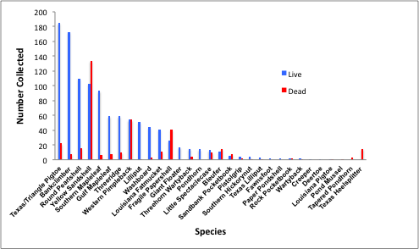
Fig. 2 Relative abundance of unionid mussels documented in the study by Ford et al. 2013-2014 in the region of the Big Thicket National Preserve. Species are listed by common name. Abundance is listed from most to least live individuals noted per species. Here, Fusconaia sp. is called TX/Triangle Pigtoe.

Fig. 3 Relative abundance of regional state-threatened unionid mussel species documented in 2017-2018.

Fig. 4 Number of individuals from each STS per unit, Big Thicket National Preserve,
Texas, 2017-2018.

Fig. 5 Relative abundance of unionid mussels documented in 2017-2018 in the Lower Neches River Corridor Unit of the Big Thicket National Preserve. Abundance is listed from most to least live individuals noted per species. *State threatened species

Fig. 6 Relative abundance of unionid mussels in the Beaumont Unit of the Big Thicket National Preserve during 2017-2018 surveys. Abundance is listed from most to least live individuals noted per species. *State threatened species

Fig. 7 Total abundance of unionid mussels documented per preserve unit, 2017-2018.

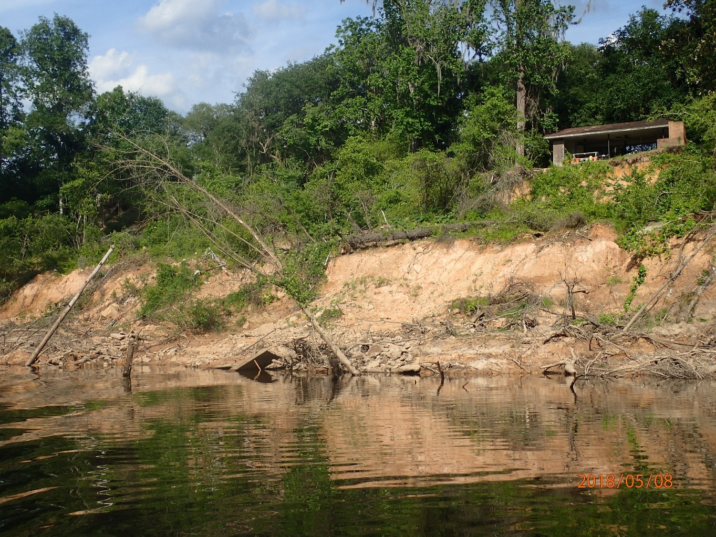
Fig. 8 Heavily eroded bank in the mid-reach of Village Creek, Hardin Co., Texas 2018.
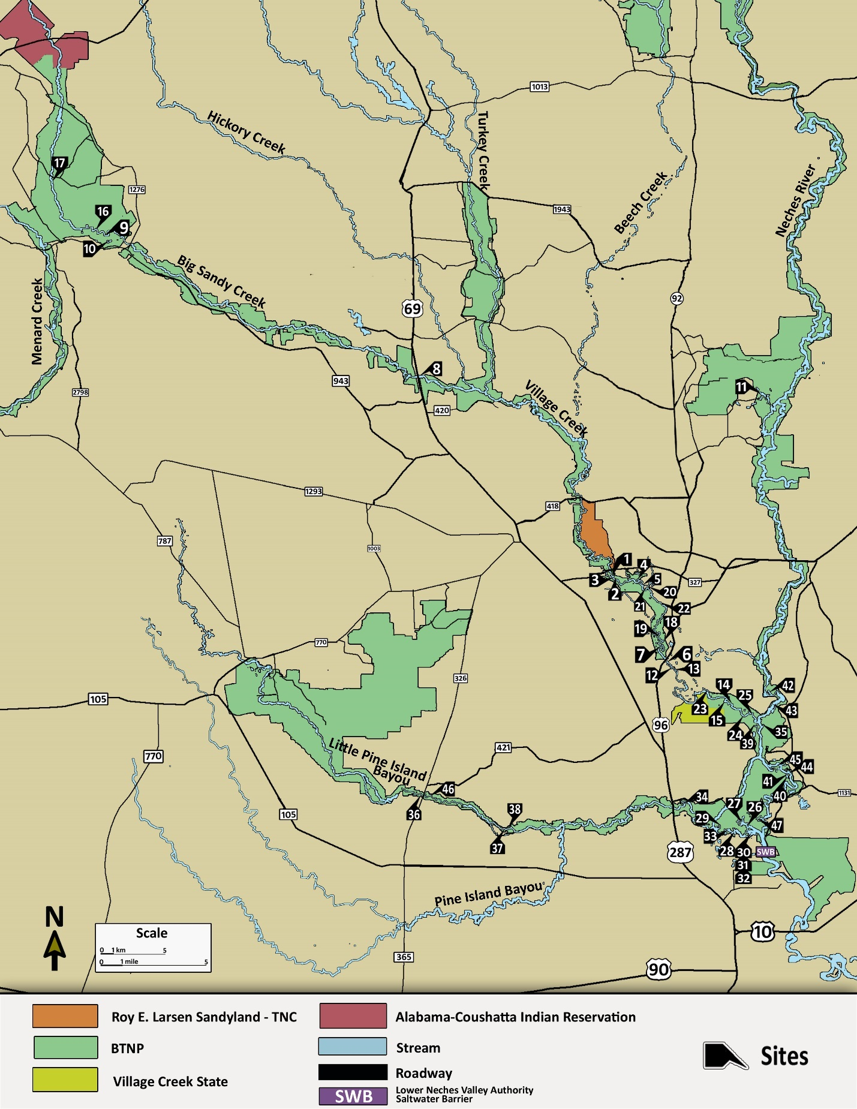
Fig. 9 Map displaying preserve units and major streams of the Big Thicket region in Southeast Texas with labeled 2017-2018 field survey sites
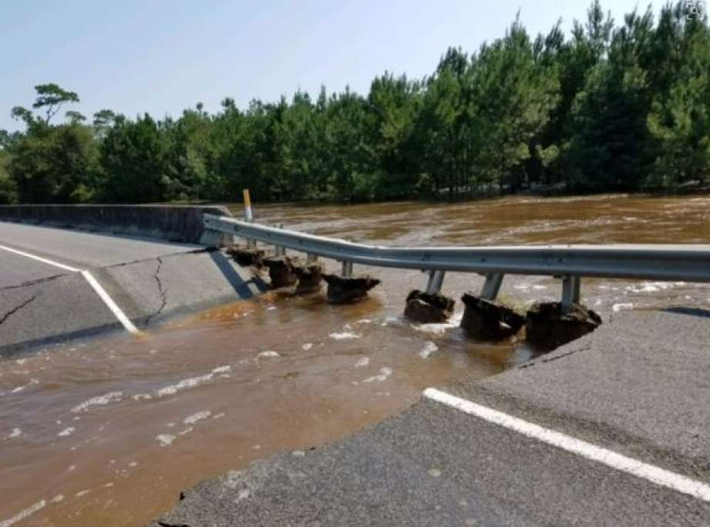
Fig. 10 On September 1, 2017, high flow resulting from precipitation during Hurricane Harvey washed out part of the US96 Village Creek bridge (survey site 6 on the map). The high-flow event and associated scour decimated what was formerly the largest documented bed of Fusconaia sp. in the region.

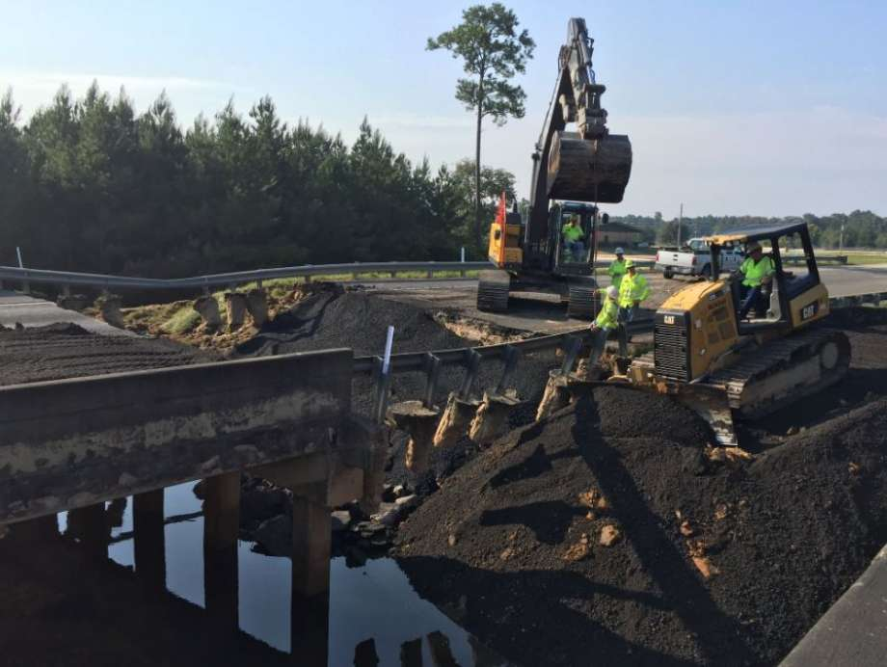
Fig. 11 Post hurricane road construction and repair activity on US96 at Village Creek near site 6

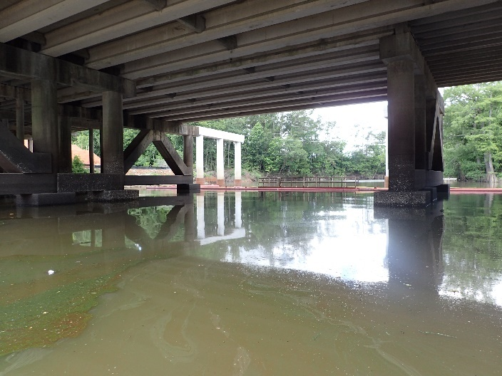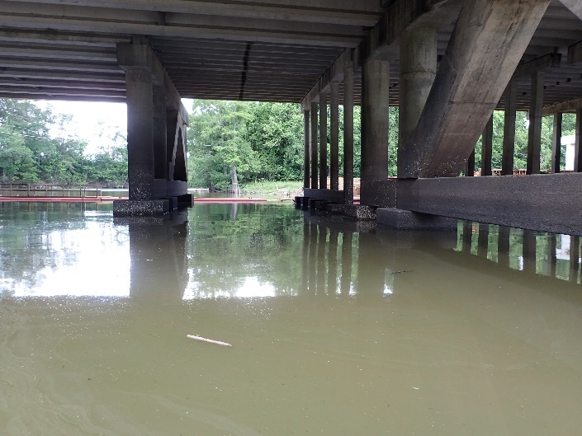
Fig. 12 Road construction activity at US96 and Pine Island Bayou obstructs upstream navigation from the Neches River. The boat ramp at this location appears to have been demolished as well.

Fig. 13 Unionid abundance per site in the Lower Neches River Corridor Unit of the BRNP, 2017-2018.

Fig. 14 Comparison of Ford et al. 2013-2014 study and the current 2017-2018 study results of Unionid diversity and abundance in the Beaumont Unit of the BTNP

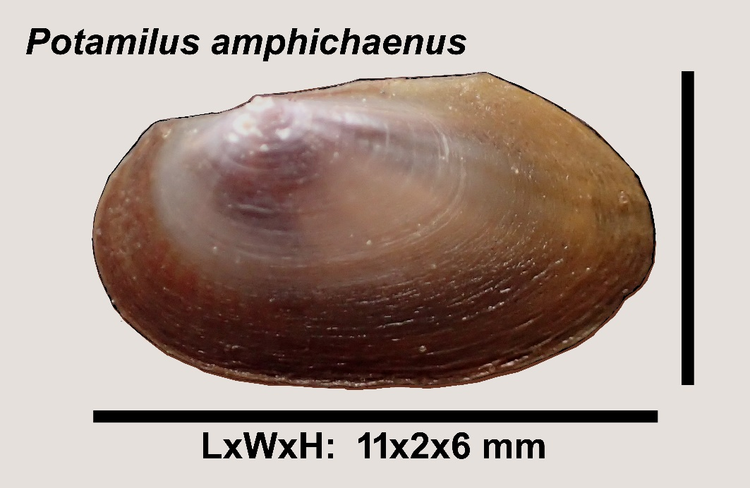
Fig. 15 Likely the smallest documented specimen on record of the endemic state-threatened species, Potamilus amphichaenus. Beaumont Unit, Big Thicket National Preserve, Jefferson County, TX.
Collected by A. Tarter, June 27, 2018.

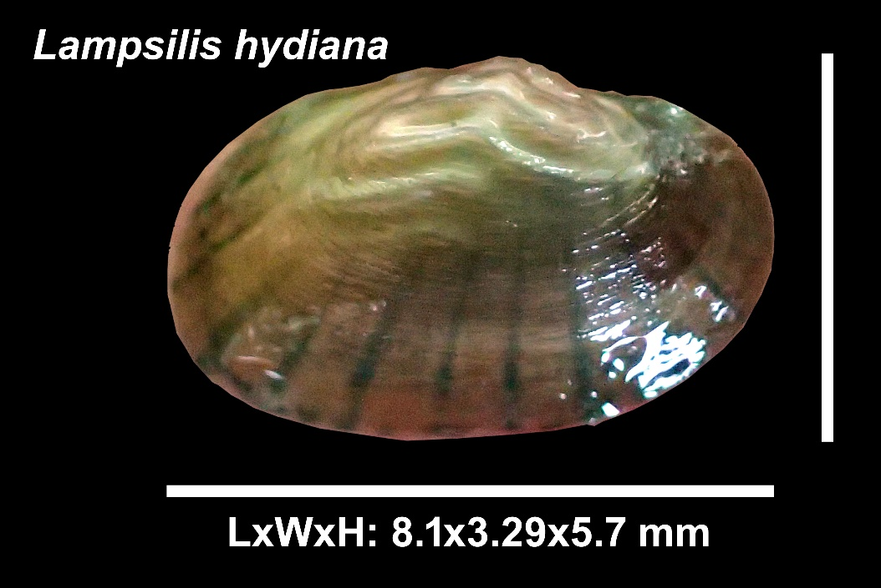
Fig. 16 Likely the smallest documented specimen on record for, Lampsilis hydiana. Beaumont Unit, Big Thicket National Preserve, Hardin County, TX.
Collected by A. Tarter, June 14, 2018.

Site # | Waterbody | Unit | County | Latitude | Longitude
1 | Village Creek | VCCU | Hardin | 30.344356 | -94.236464
2 | Village Creek | VCCU | Hardin | 30.342928 | -94.235681
3 | Village Creek | VCCU | Hardin | 30.342883 | -94.236083
4 | Village Creek | VCCU | Hardin | 30.33915 | -94.211983
5 | Village Creek | VCCU | Hardin | 30.33495 | -94.209367
6 | Village Creek | VCCU | Hardin | 30.285517 | -94.1914
7 | Village Creek | VCCU | Hardin | 30.288467 | -94.193833
8 | Village Creek | BSCCU | Hardin | 30.481383 | -94.39465
9 | Big Sandy Creek | BSCU | Polk | 30.577267 | -94.645233
10 | BSC-Swamp | BSCU | Polk | 30.576333 | -94.6432
11 | NR-Oxbow | NBJGBU | Hardin | 30.471497 | -94.115656
12 | Village Creek | VCCU | Hardin | 30.283583 | -94.1907
13 | Village Creek | VCCU | Hardin | 30.282967 | -94.1899
14 | Village Creek | VCCU | Hardin | 30.257633 | -94.143533
15 | Village Creek | VCCU | Hardin | 30.256883 | -94.144117
16 | Big Sandy Creek | BSCU | Polk | 30.578417 | -94.6457
17 | Big Sandy Creek | BSCU | Polk | 30.623617 | -94.697083
18 | Village Creek | VCCU | Hardin | 30.2937 | -94.189967
19 | Village Creek | VCCU | Hardin | 30.2958 | -94.1938
20 | Village Creek | VCCU | Hardin | 30.334722 | -94.205111
21 | Village Creek | VCCU | Hardin | 30.332067 | -94.206067
22 | Village Creek | VCCU | Hardin | 30.324483 | -94.197183
23 | Village Creek | VCCU | Hardin | 30.261567 | -94.159117
24 | Village Creek | VCCU | Hardin | 30.249038 | -94.126587
25 | Village Creek | VCCU | Hardin | 30.243833 | -94.124
26 | NR-Cook's Lake | BMT | Jefferson | 30.1737 | -94.126783
27 | NR-Cook's Lake | BMT | Jefferson | 30.1754 | -94.1324
28 | Pine Island Bayou | BMT | Jefferson | 30.164017 | -94.125967
29 | Pine Island Bayou | BMT | Hardin | 30.1725 | -94.151267
30 | Pine Island Bayou | BMT | Hardin | 30.166717 | -94.12405
31 | Pine Island Bayou | BMT | Hardin | 30.166717 | -94.124717
32 | Pine Island Bayou | BMT | Hardin | 30.165967 | -94.123917
33 | Pine Island Bayou | BMT | Hardin | 30.165583 | -94.139867
34 | Pine Island Bayou | BMT | Hardin | 30.1858 | -94.17975
35 | Neches River | LNRCU | Orange | 30.240533 | -94.116383
36 | Little Pine Island | LPIPIBCU | Hardin | 30.1892 | -94.389467
37 | Little Pine Island | LPIPIBCU | Hardin | 30.1632601 | -94.31726
38 | Little Pine Island | LPIPIBCU | Hardin | 30.163366 | -94.316967
39 | Neches River | LNRCU | Hardin | 30.239183 | -94.11835
40 | Neches River | BMT | Hardin | 30.199533 | -94.094617
41 | Neches River | BMT | Hardin | 30.2001 | -94.093967
42 | Neches River | LNRCU | Jasper | 30.26435 | -94.110067
43 | Neches River | LNRCU | Hardin | 30.25545 | -94.104167
44 | Neches River | BMT | Orange | 30.203767 | -94.092667
45 | Neches River | BMT | Orange | 30.211317 | -94.101867
46 | Little Pine Island | LPIPIBCU | Hardin | 30.189183 | -94.386817
47 | Neches River | BMT | Hardin | 30.173733 | -94.1176

