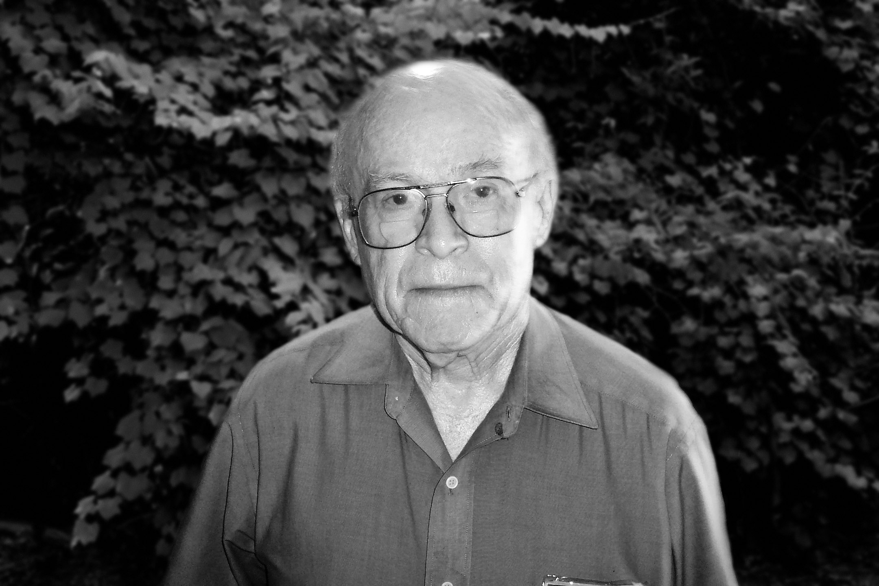
BIG THICKET ASSOCIATION
P.O. Box 198
Saratoga, TX 77585-0198

Dr. Larry Brown
Dr. Larry Eugene Brown
1937-2020

Dr. Larry Brown, the Plant Man, was the recipient of the Big Thicket Association’s R.E. Jackson Conservation Award 2012. The award descends from the Conservation Awards begun by the Big Thicket Conservation Association. It is named after R.E. Jackson who began the Big Thicket preservation movement in the late 1920’s. This prestigious award recognizes leadership and service and extraordinary and outstanding contributions to conservation and scientific research.

Brown earned his Ph.D. from Texas A&M University in 1969 and served as an instructor of Biology at Houston Community College from 1976 until his retirement in 2006. In addition, he was a visiting instructor at Rice University and taught Botany at California State Polytechnic University at San Luis Obispo, Ca. from 1969-71.

Dr. Brown was a Vascular Plant Inventory Group Leader for the Big Thicket Association’s Thicket of Diversity. He consistently assisted students and professionals with plant identification and lent his expertise in identification of plant materials. Brown’s work is now part of a National Park Service database and assists stewardship decision making of resource managers. He has also contributed to work with Texas Parks and Wildlife Department, the Mercer Arboretum and Botanical Gardens, US Fish and Wildlife Service, the Trinity River National Wildlife Refuge and others.

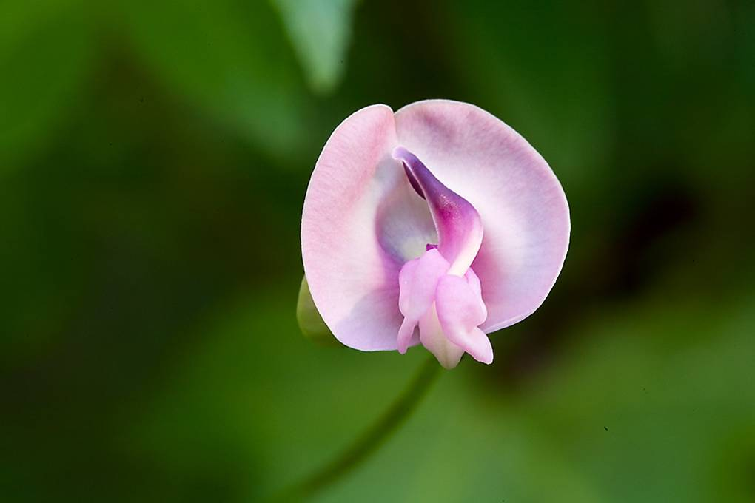
The taxonomist’s prolific research is documented through publications and collections housed at the Spring Branch Science Center Herbarium in Houston. It includes published annotated check lists of the vascular flora of the Turkey Creek Unit, Big Sandy Unit, Lance Rosier Unit, Beech Creek Unit, Loblolly Unit, Menard Creek Corridor Unit, the Neches Bottom Unit, and the Jack Gore Unit of the Big Thicket National Preserve.

In 2002 Dr. Larry Brown was recognized with the Native Plant Society’s Charles Leonard Weddle Memorial Award for lifetime achievement in the field of Texas native plants.

Dr. Brown’s floristic work has resulted in at least four species new to Texas plus one species new to Arkansas and one new to Louisiana.

R. E. Jackson Conservation Award Recipients:
1984 - Archer Fullingim
2004 - Professor Pete Gunter
2005 - Cong. Charles N. Wilson
2006 - Billy Hallmon
2007 - Ann Roberts
2008 - Wendy Ledbetter
2009- Brandt Mannchen
2010- David Lewis
2011 Senator Kay Bailey Hutchison

1985 - Sen. Ralph W. Yarborough
1990 - Geraldine Watson
1993 - Professor Claude McLeod
1994 - William B. Jewell
1999 - Professor Paul Harcombe
2000 - Arthur Temple, Jr.
2001 - Edward C. "Ned" Fritz.
2003 - Charles E. Hunt
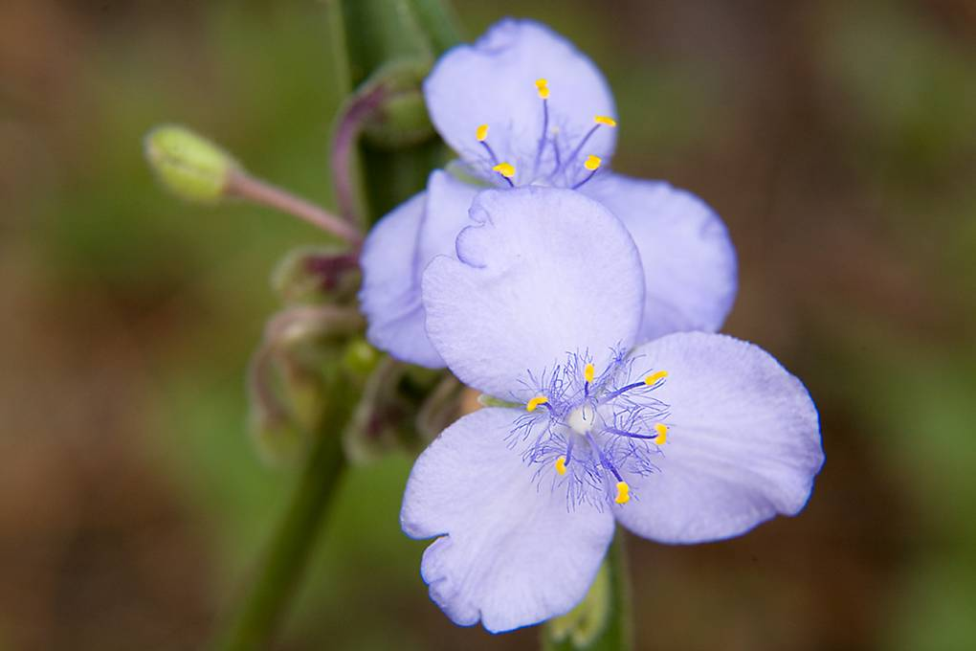

Photographs: Michael Black

