Matthew Pyne
Assistant Professor of Biology
Office: 205-11 Hayes Biology Building
Phone: 409-880-7458
Email: mpyne@lamar.edu
Curriculum vitae

Education:
2014 Ph.D. in Ecology, Colorado State University
2006 M.S. in Integrative Biology, Brigham Young University
2003 B.S. in Wildlife and Range Resources, Brigham Young University

Courses Taught:
Ecology (BIOL 4460/5460)
Limnology (BIOL 4430/5430)
Aquatic Entomology (4480/5480)
Anatomy and Physiology 1 (BIOL 2401)
Graduate Seminar (BIOL 5110)

Research Interests:
My research interests lie in understanding the relationship between the distribution of aquatic organisms and the structure, climate, and hydrology of freshwater aquatic systems. I aim to integrate statistical modeling and experimental research to better understand how aquatic communities are changing according climate change and anthropogenic influences. I am particularly interested in exploring the relationships between traits and environmental gradients. Current projects include:

  - Conducting a survey of American alligators (Alligator mississippiensis) along a river corridor between coastal and inland alligator habitats
  - Experimentally manipulating stream temperatures to measure how aquatic insects can alter life history characteristics to mitigate the effects of climate change.
  - Predicting the future distribution of aquatic insect taxa in western U.S. streams using aquatic insect traits and large and small scale environmental and climate variables.
  - Surveying the distribution of the brackish water clam, Rangia, and modeling its distribution in relation to salinity fluxes in the Neches River.
  - Predicting the distribution of pitcher plants in the Big Thicket Preserve
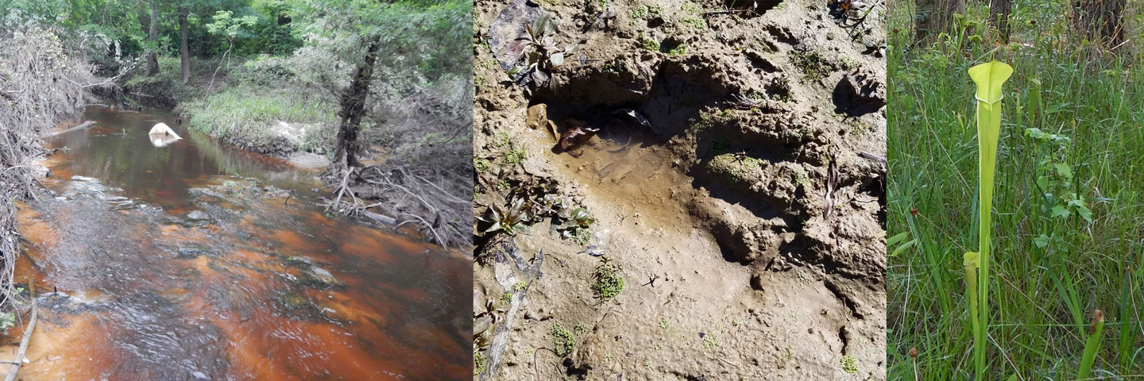

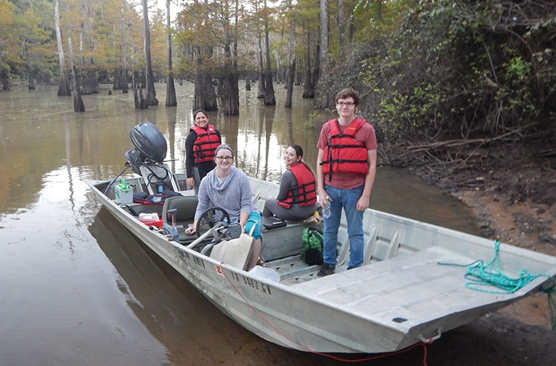

Research Group:

Graduate Students:
Jami Brown (2017-)

Undergraduate Researchers:
Jean-Luc Baker
Tara Forst
Katie Harmon
Veronica Hobbs
David Narvaiz
Joseph Patin
Billie Walters
Emmett Worsham

Selected Publications:
Christensen, A. B., K. O. Radivojevich, and M. I. Pyne. 2017. Effects of CO2, pH and temperature on respiration and regeneration in the burrowing brittle stars Hemipholis cordifera and Microphiopholis gracillima. Journal of Experimental Marine Biology and Ecology 495: 13-23 (DOI: 10.1016/j.jembe.2017.05.012)
Pyne, M. I., D. M. Carlisle, C. P .Konrad, and E. D. Stein. 2017. Classification of California streams using combined deductive and inductive approaches: setting the foundation for analysis of hydrologic alteration. Ecohydrology: DOI: 10.1002/eco.1802
Pyne, M. I., and N. L. Poff. 2017. Vulnerability of stream community composition and function to projected thermal warming and hydrologic change across ecoregions in the western United States. Global Change Biology 23 (1): 77-93 (DOI: 10.1111/gcb.13437).
Poff, N. L., M. I. Pyne, B. P. Bledsoe, C. C. Cuhaciyan, and D. M. Carlisle. 2010. Developing linkages between species traits and multiscaled environmental variation to explore vulnerability of stream benthic communities to climate change. Journal of the North American Benthological Society 29:1441-1458.
Pyne, M. I., K. M. Byrne, K. A. Holfelder, L. Mcmanus, M. Buhnerkempe, N. Burch, E. Childers, S. Hamilton, G. Schroeder, and P. F. Doherty. 2010. Survival and breeding transitions for a reintroduced bison population: a multistate approach. Journal of Wildlife Management 74:1463-1471.
Webb, C. T., J. A. Hoeting, G. M. Ames, M. I. Pyne, and N. L. Poff. 2010. A hierarchical and dynamic framework to advance traits-based theory and prediction in ecology. Ecology Letters 13: 267-283.
Pyne, M. I., R. B. Rader, and W. F. Christensen. 2007. Predicting local biological characteristics in streams: a comparison of landscape classifications. Freshwater Biology 52:1302-1321.

